Basic reset with the universal selector

To render the page in the exact same way across browsers

Change box model (box-sizing: border-box)

The borders and paddings are not longer added to the total width or total height that we specify for a box

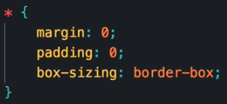



Makes the image to resize on resize window.



Makes the top of the image to be kept on resizing.

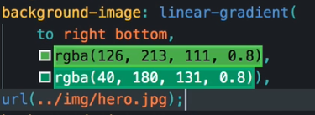

Color with opacity over floating the image so it will look like degradant.

Padding over the body will make the padding for the whole page

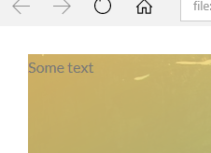

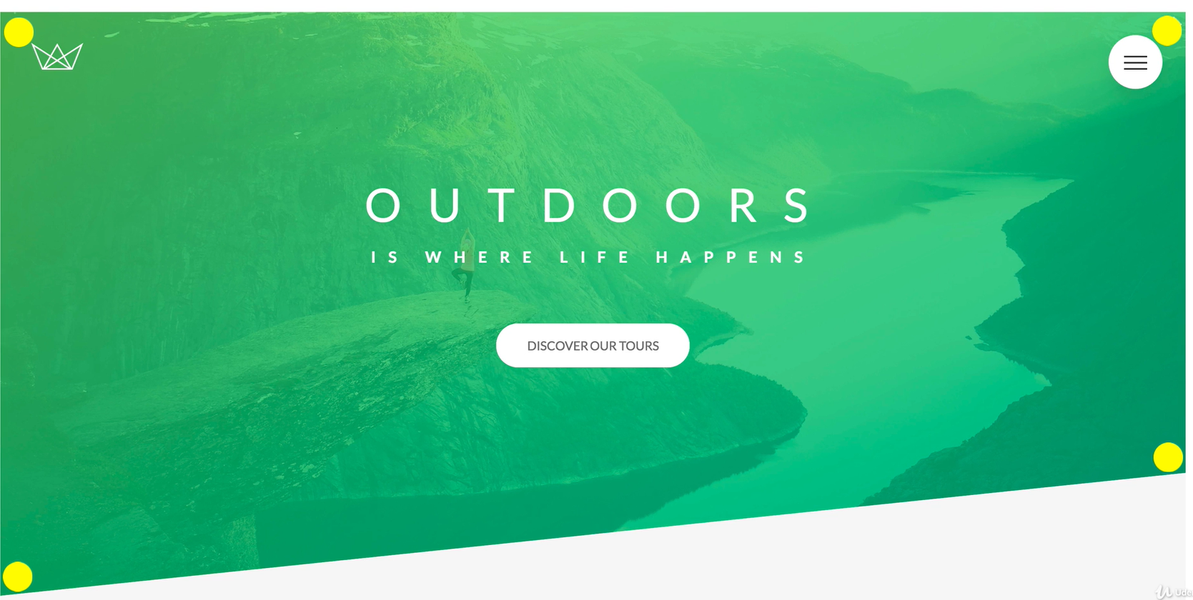

Clip path, allows to mark from which coordinates the image should still be showing



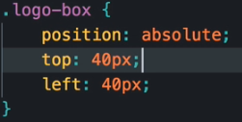

Position from where it will start considering 40px to left and top is from the parent element with relative position.

Block elements occupy the entire width that they have available, and create line breaks after and before them

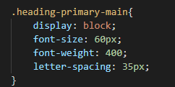

Letter-spacing, adds the specified space between each letter



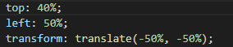

Top and left are considered from the parent

Transform translate from the element itself will start the positioning

Css Animations

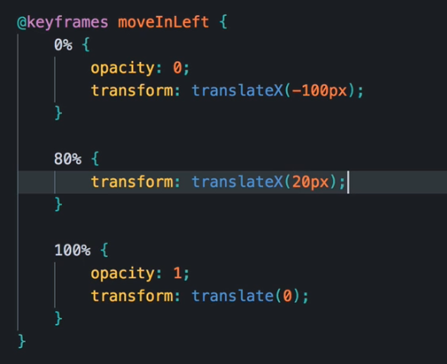

Animation properties, 0% when the animation begins, all the way to 100% that is when it finishes.

Translate(0) then it will be in its actual without animation state.

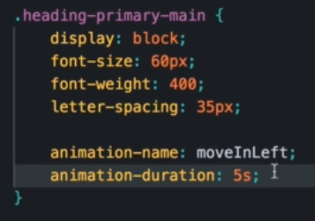

The created animation is used in one of the rules which will execute the animation properties to it.



Animation happens that number of times



Waits those seconds and then starts with the animation

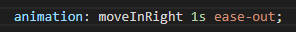

Shortcut

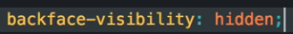

Fix for back part visibility on transform



Rotates the text as part of the animation

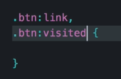

:link, state that exists for <a>

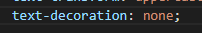

For example, on links remove the behavior of an underline, etc



We should use if we want to give to the element some padding, height or width



When you click the button

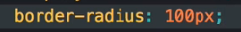

Oval box





Goes in the rule from the initial state, will produce an effect from the initial state to the next with a transition effect



Shadow on the box : x y blur shadow color



Pseudo elements

Allows to style certain parts of elements

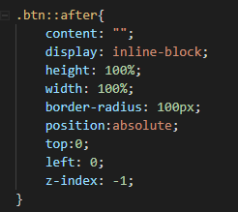



Allows to increase the element (2== double the size it had before)



Automatically apply the styles up to zero percent before the animation starts

Responsive design

It works correctly on all screen sizes

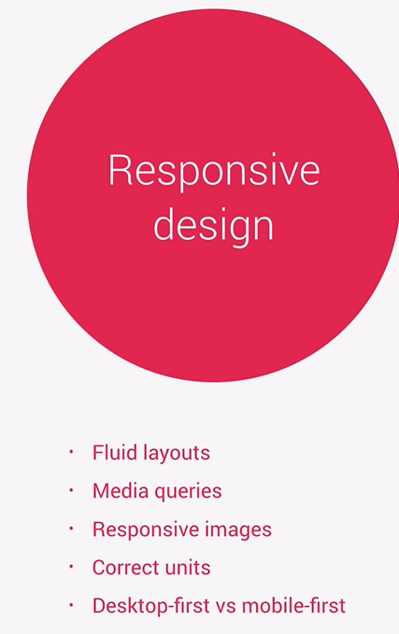 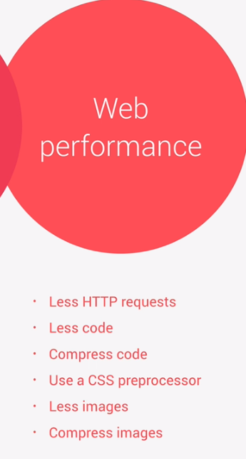

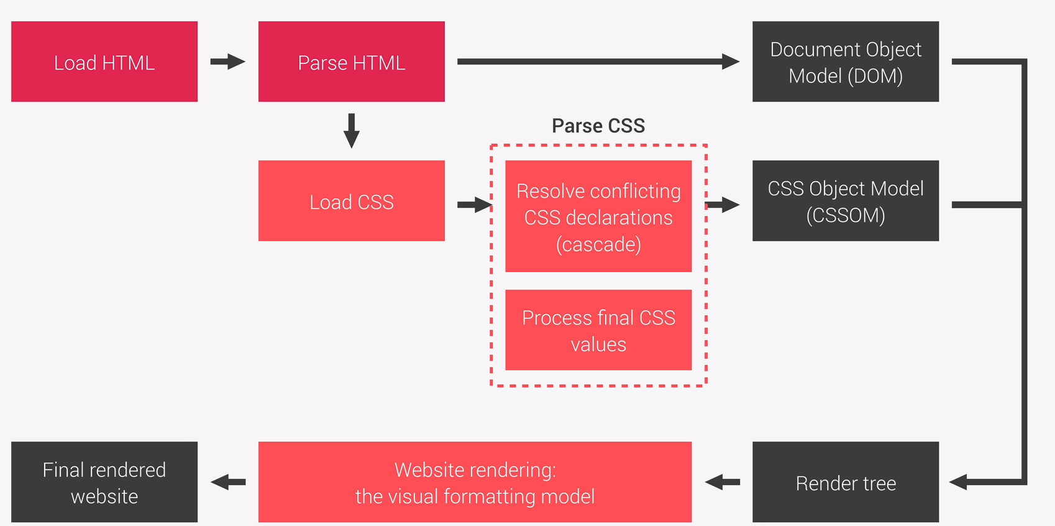

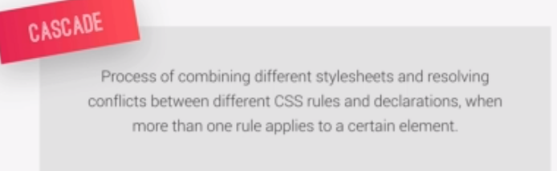

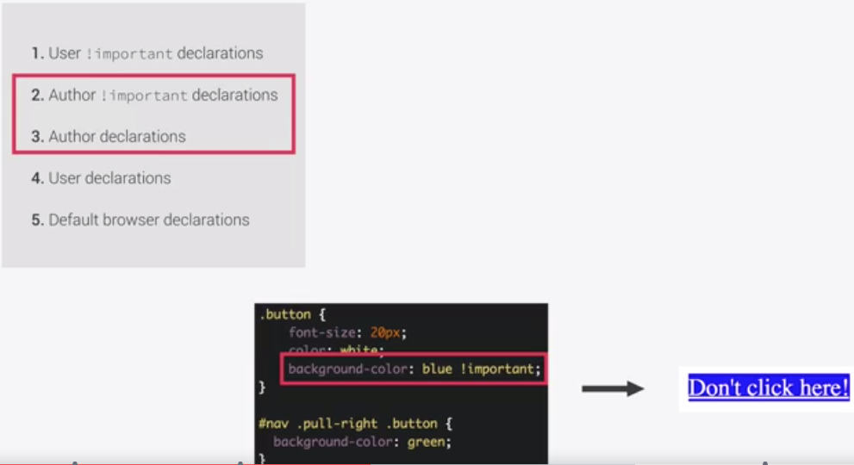

Rules with !important have the highest priority

When same importance (written by the same user or author)

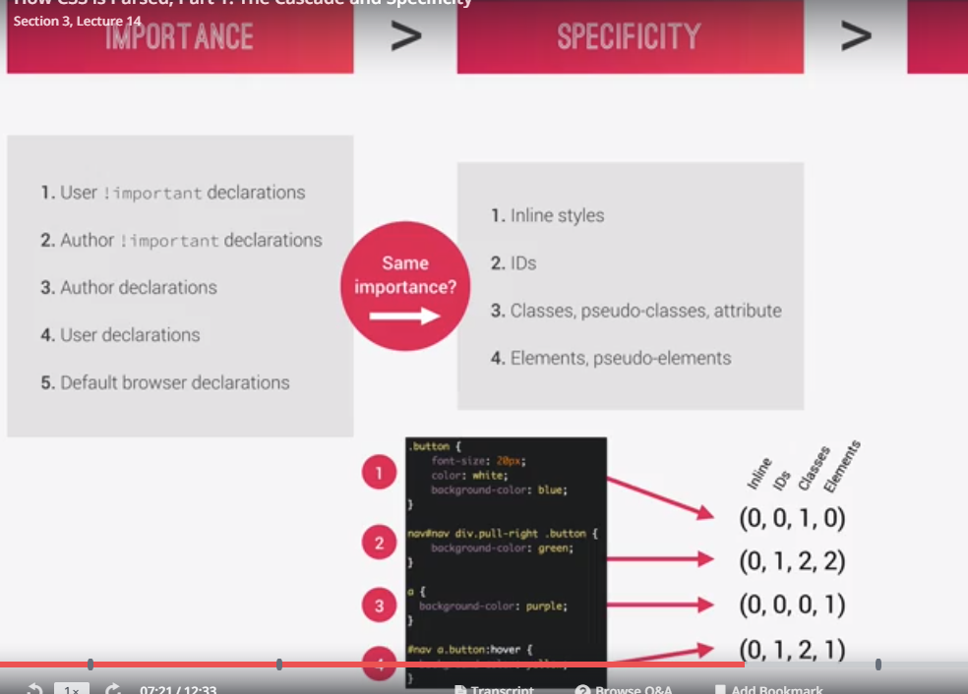

Which rule will apply is based in the numbers, if there is one with inline, then this one will apply, if 2 would have a 1 in inline, then it will compare based on the next number to the right and that way all the way to the right

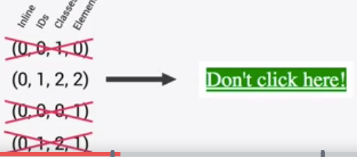

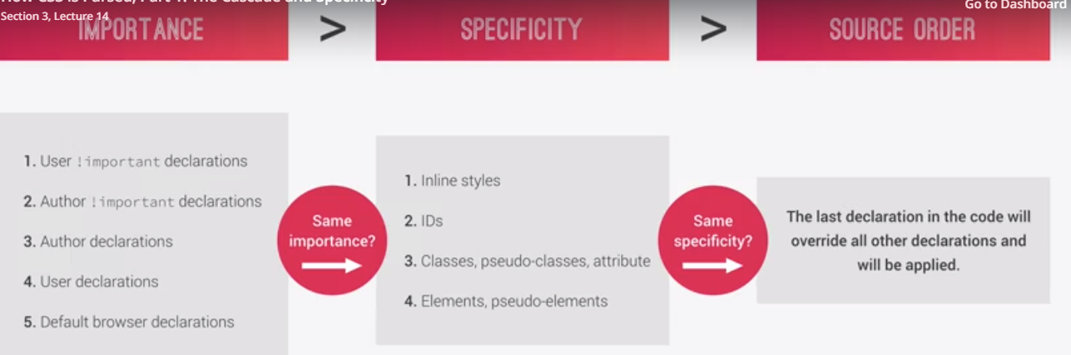

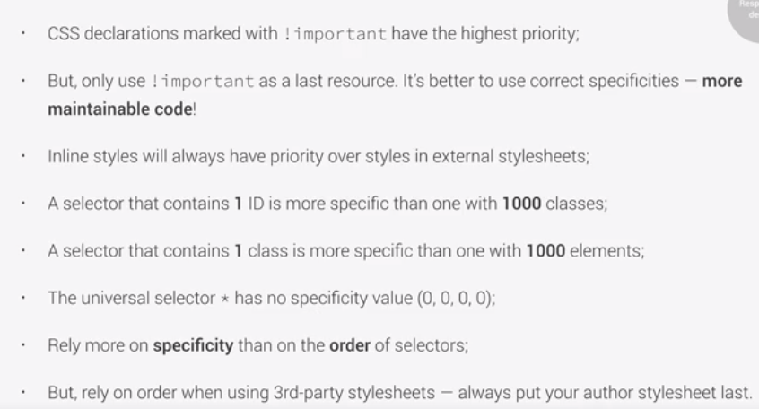

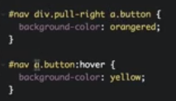

On these rules, the hover wouldn’t be applied, the issue is, the :hover counts as a class for the specificity so it is still bigger the second one, we would need to match the selector to then with the : hover be higher than the other rule and then be applied

Values like em or % are converted in the process to px

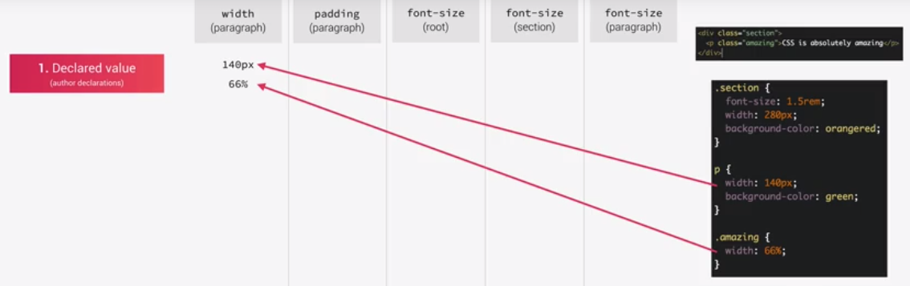

P and .amazing width conflict, the one who will be rendered is determined by specificity, in this case .amazing will be

Width % is In relation to its parent

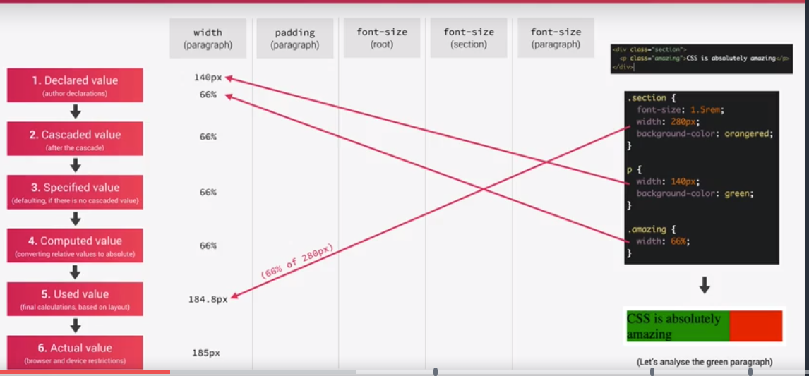

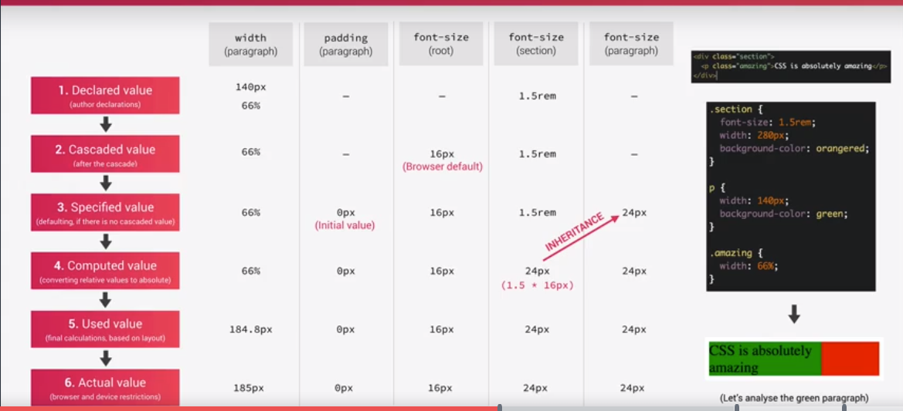

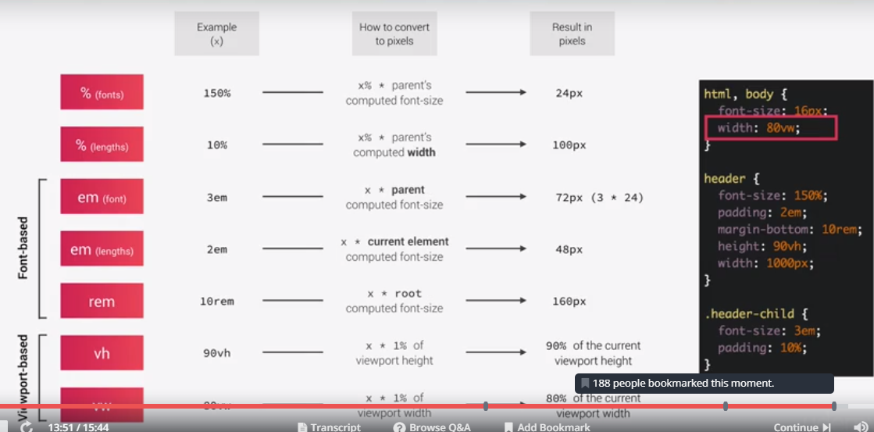

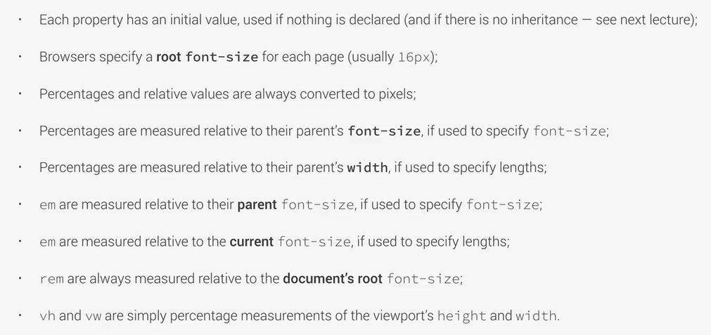

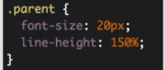

Line-height = 30 px

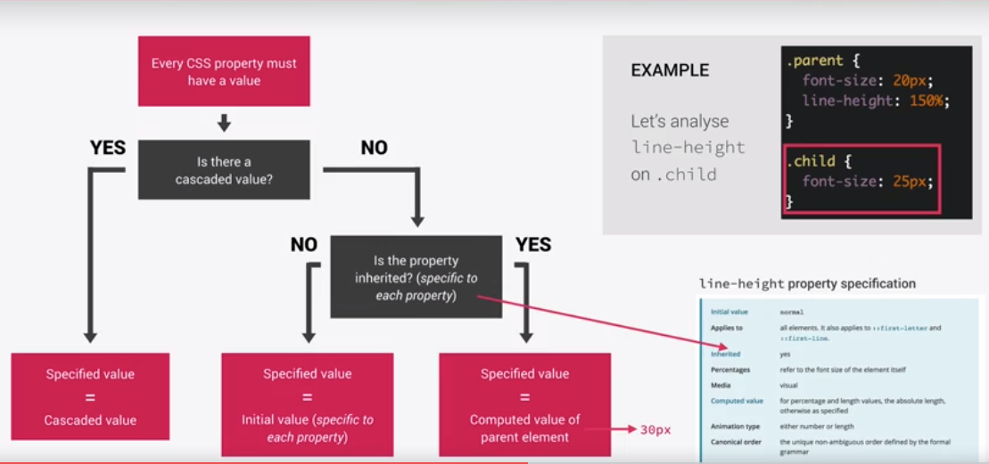

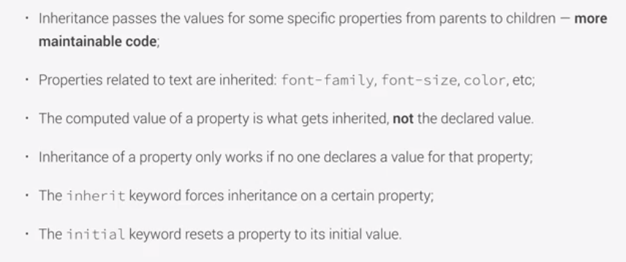

Rem unit always in relation to the root font size

If you declare font size on the root as a css rule, then it will be easy to modify its values later (change all rem at the same time)

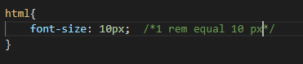



Correct approach is using percentage, in case user change the browser default

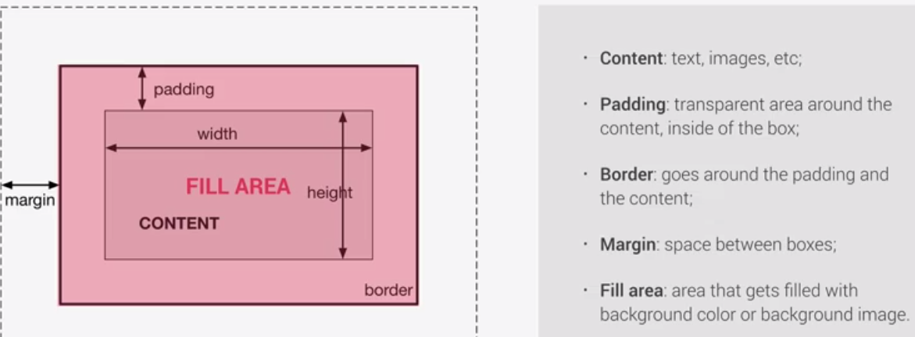

We can choose the width and height of an element, in case we don’t do it, it will be calculated based on the next

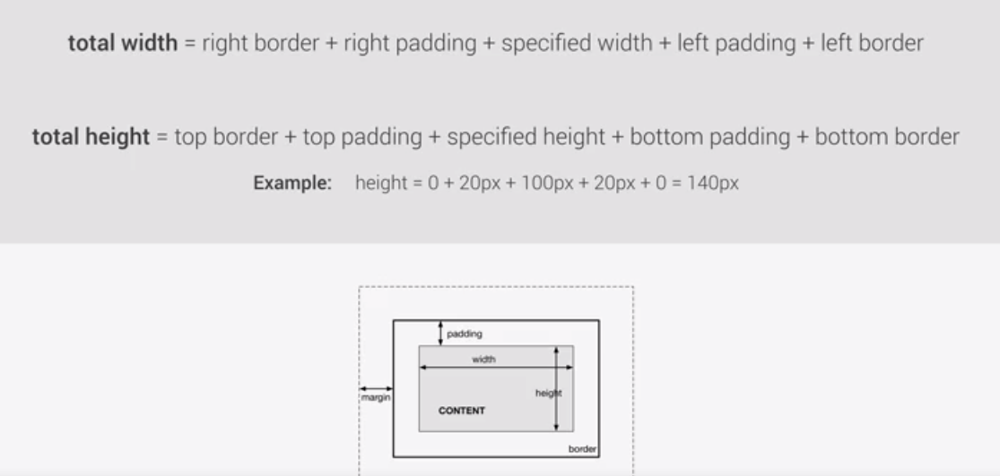

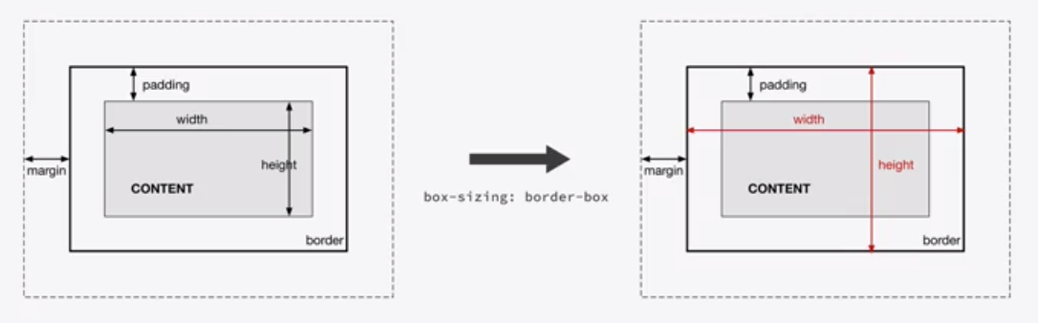

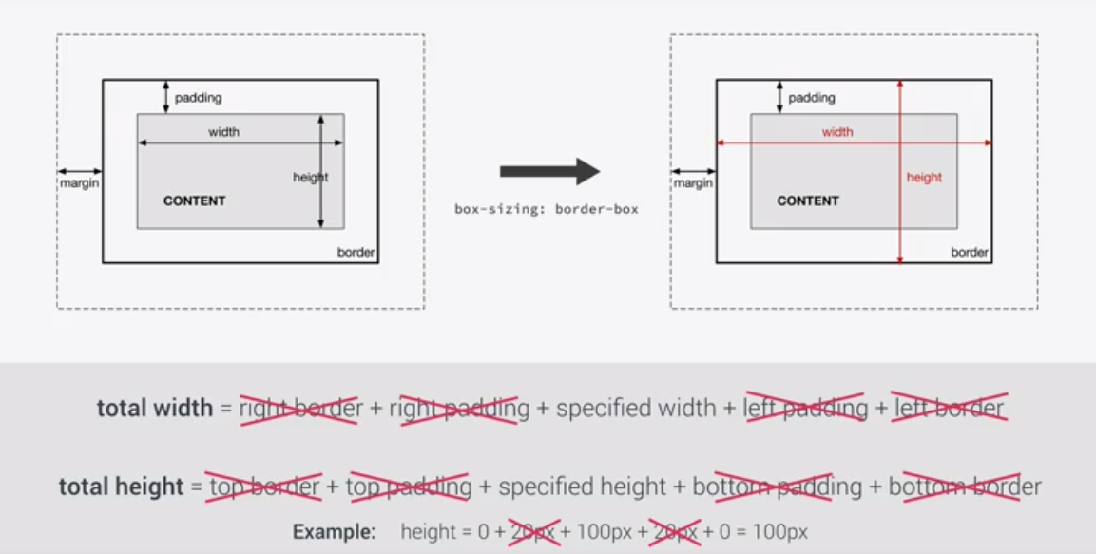

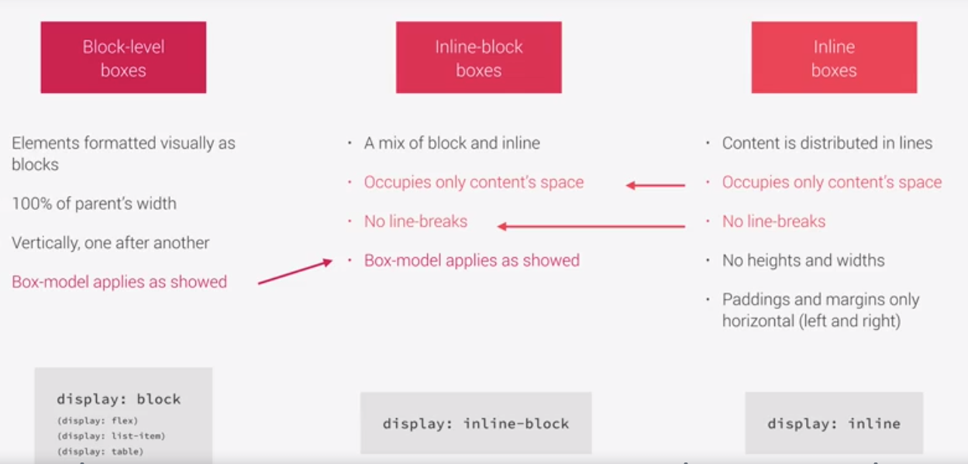

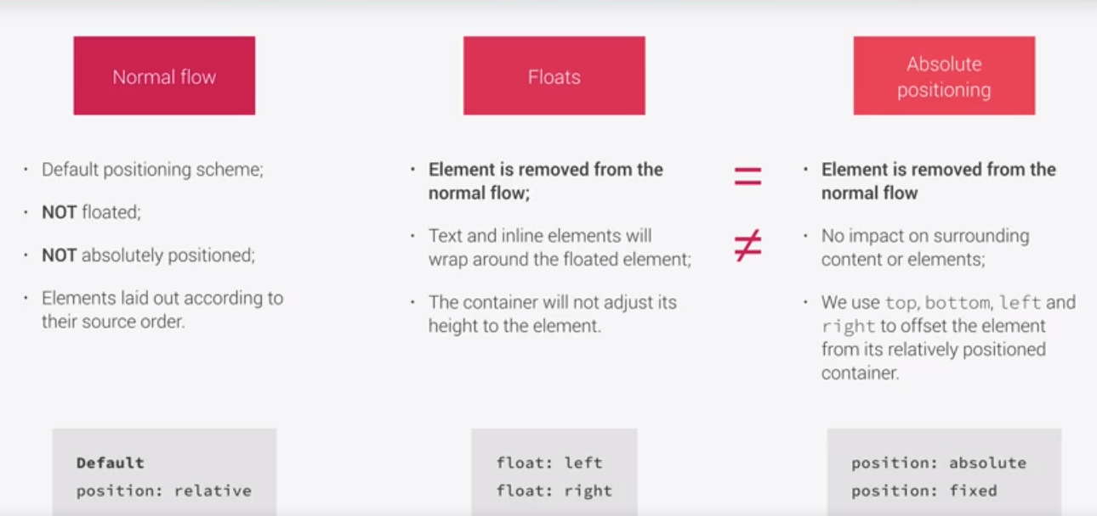

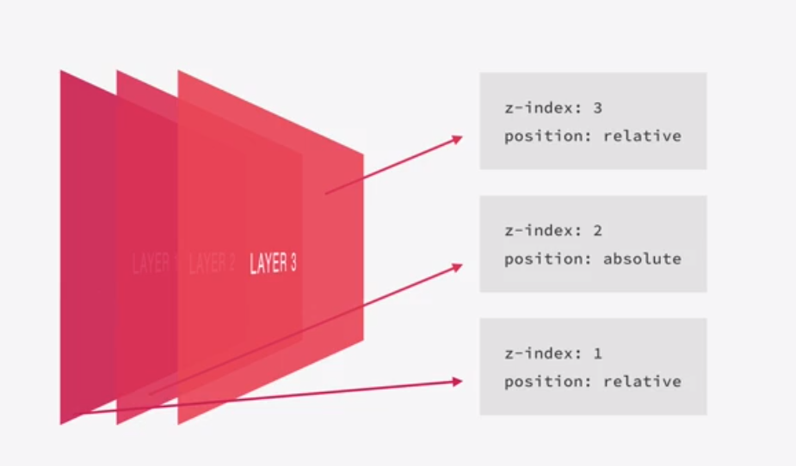

Sass

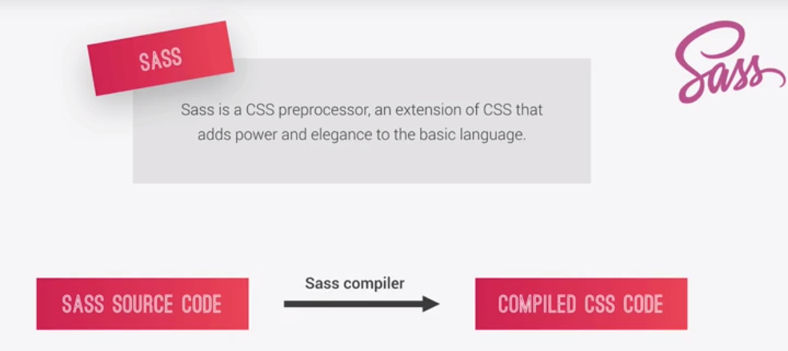

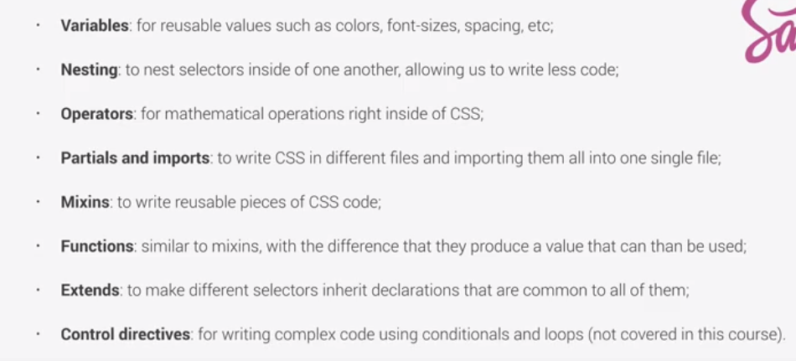

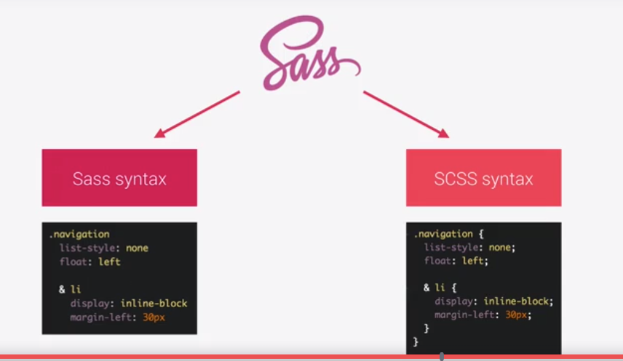

When the rule is inside another in sass, if its part of the tree the & is not required

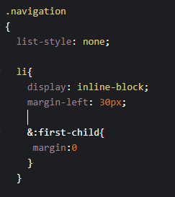

First child is not a part of the dom tree, hence it requires the &

Var declaration





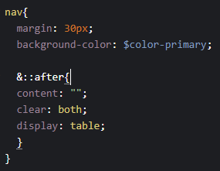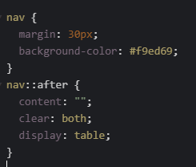

Nested rules on scss will produce the normal css rule



Makes the mentioned color more dark



Makes the color lighter

Mixin

Reusable piece of code (like huge variable)

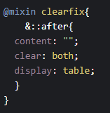 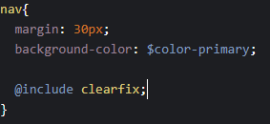

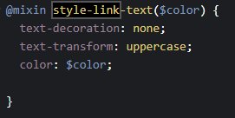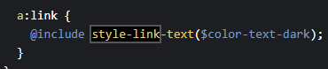

Function

Can receive input, does something and then returns a value

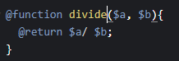



Extend

Extend the code from a placeholder

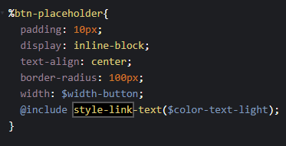 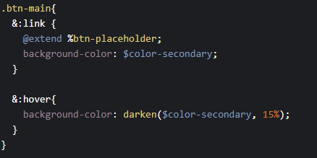

The selector which uses the placeholder is then replace on the %btn-placeholder, not like the mixin which takes the code on the mixin and add it on the used place

Compile sass to css file

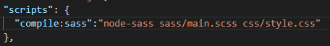

Live-server



Compile sass



Keep watching sass changes to auto compile

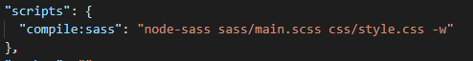

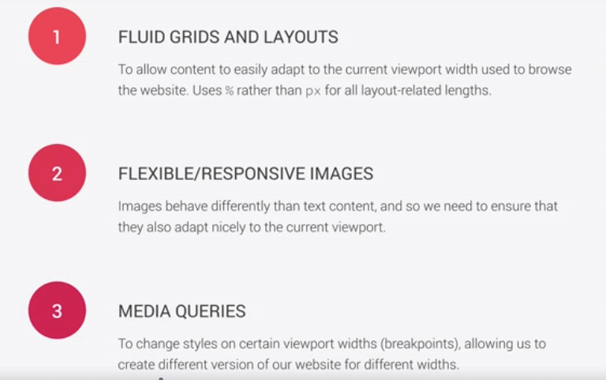

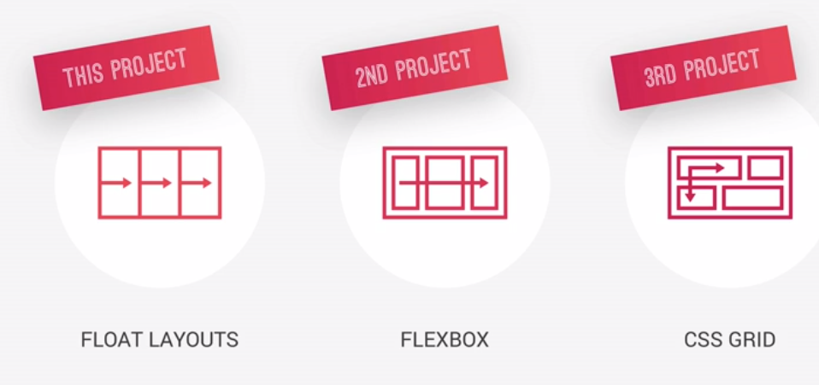

Max width:

If it has enough available space, the width will be the one we specified, if not, the viewport is smaller than the width we specified here, then it will be the 100% of the available space

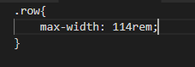



Center block elements inside another block element (margin top and bottom 0, left and right auto) with auto after checking the width of the page it will be set equal for both

Not(:last-child)

Will apply to all except the last matching child

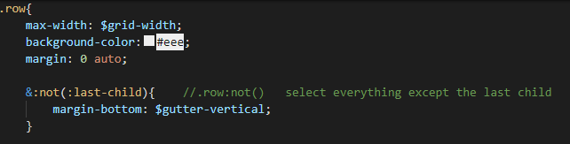

Calc()

Allows us to make calculations where we can mix units



When we float all elements in the box, then its height is 0. Clearfix hack fix it.

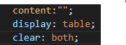

Starts with selector

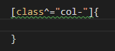

Rotates text

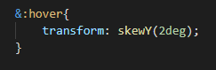

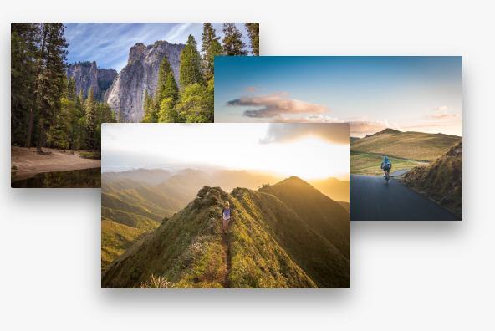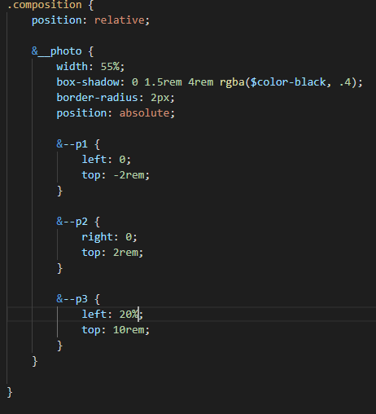

Position absolute on the images, then they will be positioned based on its parent (.composition) which needs to be relative

Make over image on top than the rest, all images z index = x and then on over zindex will be set to more to be on top

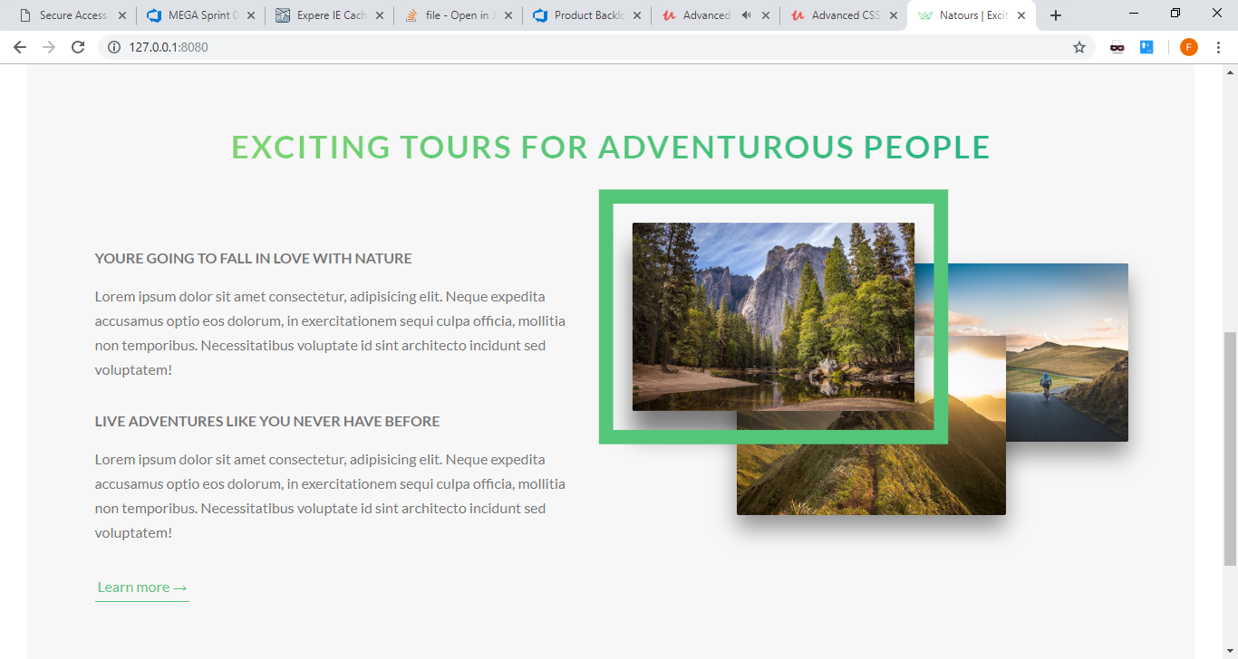

Outline add the border, outline-offset adds the space between the border and the actual element



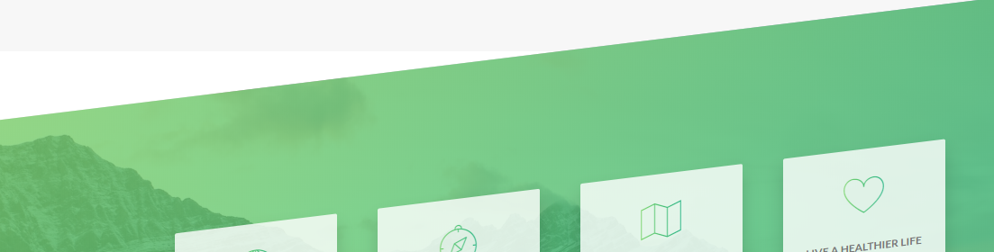

Incline the box

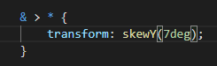

Selector to select just the direct child



Fix the aligment with 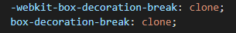

 centered block inside other block

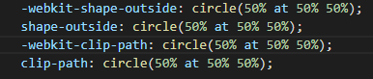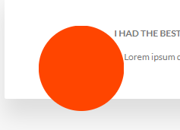

Make it look like a circle, it needs width, height and float.



Blur distortion the img and brightness makes is darker if -100%

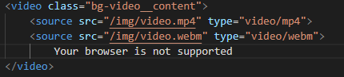

To add video, if not supported then the message will be displayed





Works with images and videos to fit all the size correctly



100% of the width





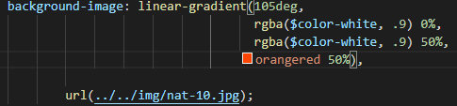

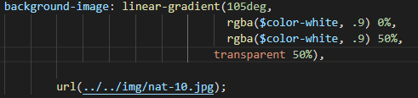



Keeps the space of the border, but don’t show it up

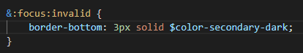

Applies when the input is on focus and It doesn’t have valid data

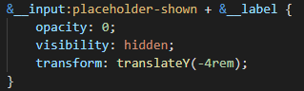

Opacity will make it invisible, but still on the page

Visibility hidden will remove from the page

+ &__label will apply for the first next sibling only

:placeholder-shown, will apply if the placeholder is being shown

Transform will make an animation to move it 4 rem



Similar to absolute, but it doesn’t change its position when you scroll the page



Starts from the center and then it goes from there in all the outside directions

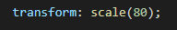

Makes the effect to go bigger so it covers the page from what it is below







Moves element 1 rem to the right (needs display inline-block)

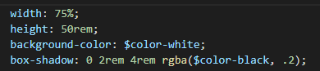

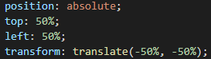

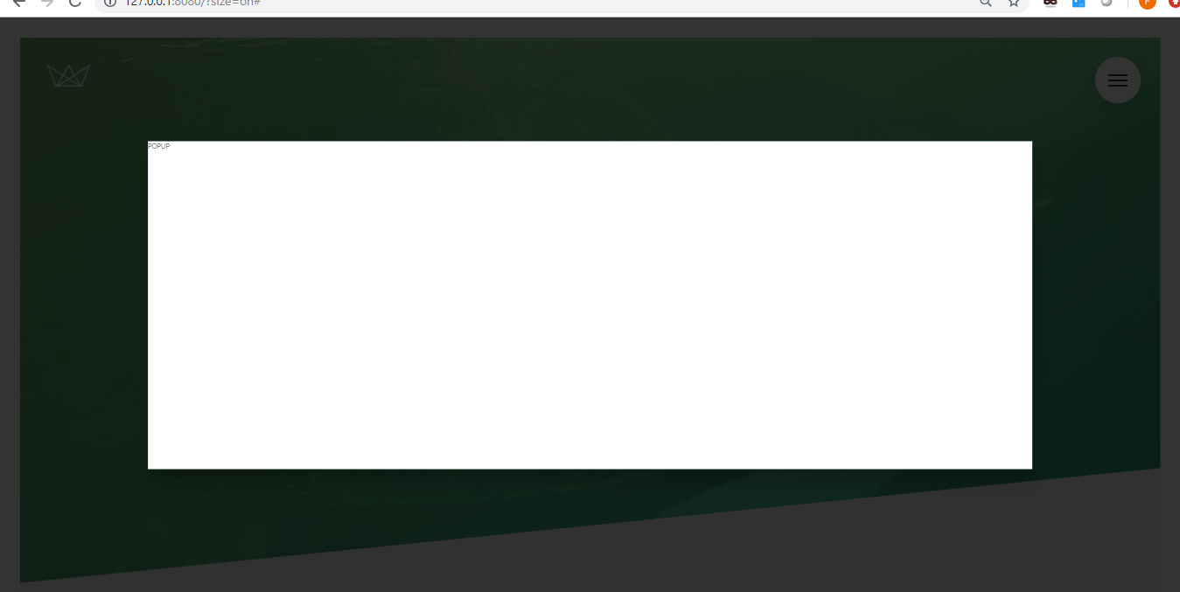

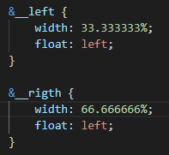

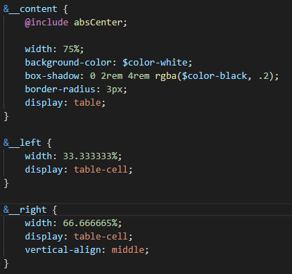

Display table on parent, display table cells on childs make it look as a table of the same height where you can align vertically



The part which overflows the content will not be visible

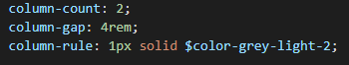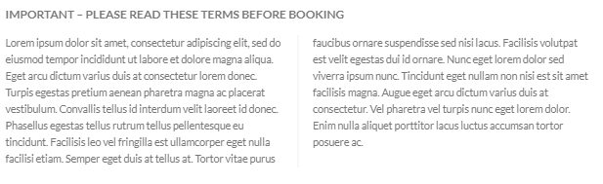

Divides the text in the number of columns specified, gar adds space between them, rule added the border between columns



Adds hyphens (-) on the cut words where it corresponds, needs the language to be specified on the html





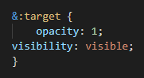

When you click the <a> whith targets the #popup, it will apply the css with pseudo :target of the element

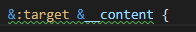

When becomes the target apply the style to its child element &__content



You can only have one transform rule, if by inheritance you get 2, the first one is overwritten, for that you need to add the previous transform rule on the second one to apply both



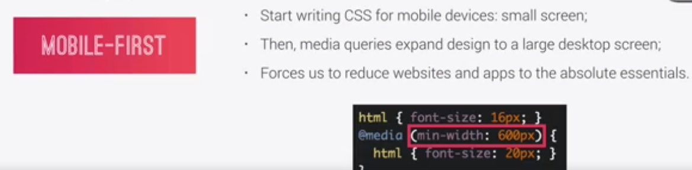

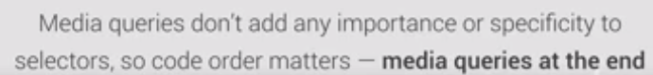

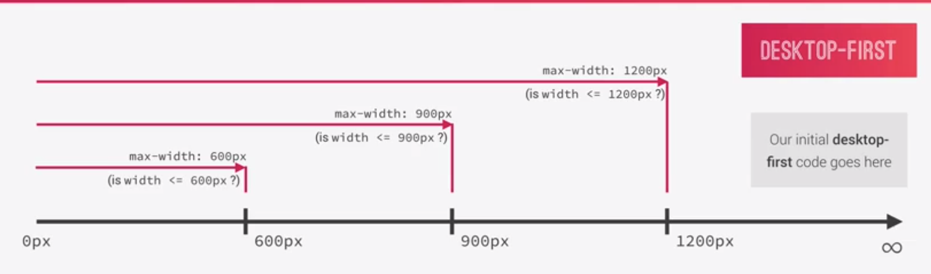

500px all media queries 600,900,1200 will apply (if there are rules in conflict the last ones will be applied)

Max-width (for desktop first approach)

Max width at which the media query will apply

 for mobile first approach



Breakpoint

Where media queries will apply (ex device width)

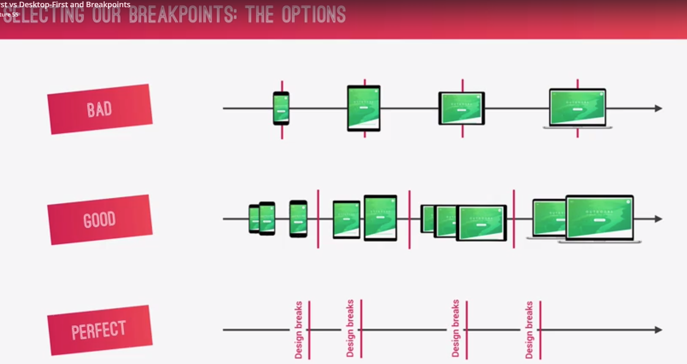

Good, take similar devices and group them as breackpoints

Perfect, you start to add breakpoint whenever the site starts to look weird

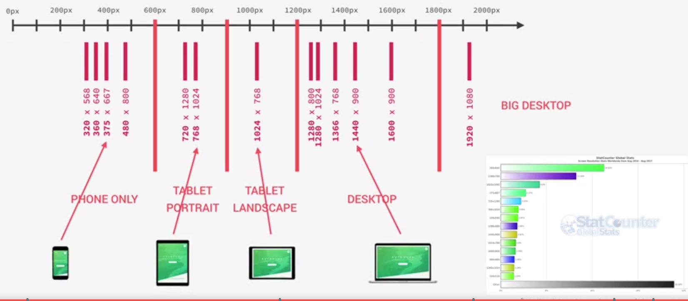

One common approach, create another css file and there simply write a big media query with html, body, etc (one media query per breackpoint)

Another way add the media query on the selector which we want to be responsive

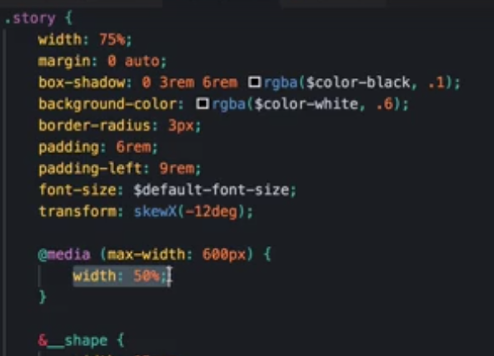

Media will apply to story class widh width < 600px

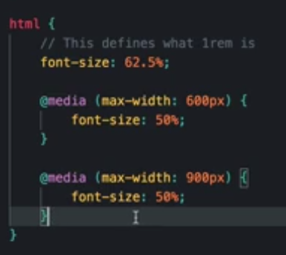

Best way, create a mixin and then use them

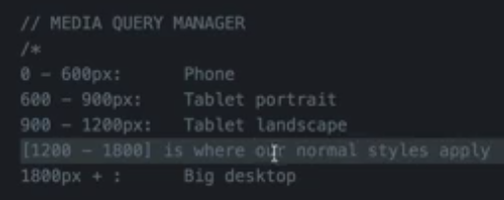

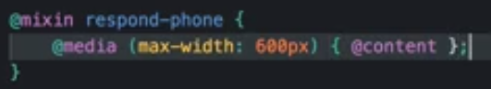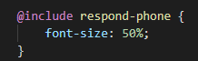

Mixin defined, the @content will be replaced for the rule or rules added on the element using the mixin

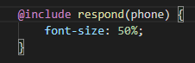

1em = 16px

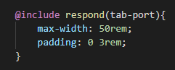

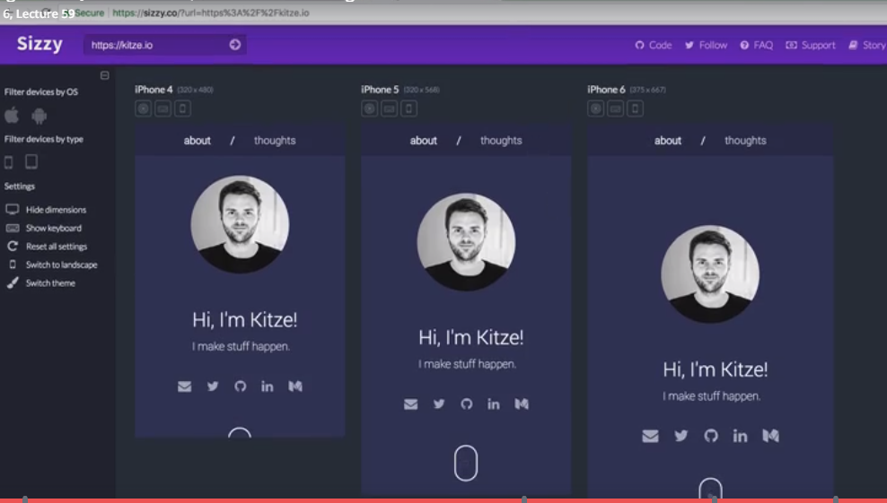

Responsive images

Crucial for web performance, identify and send the proper image

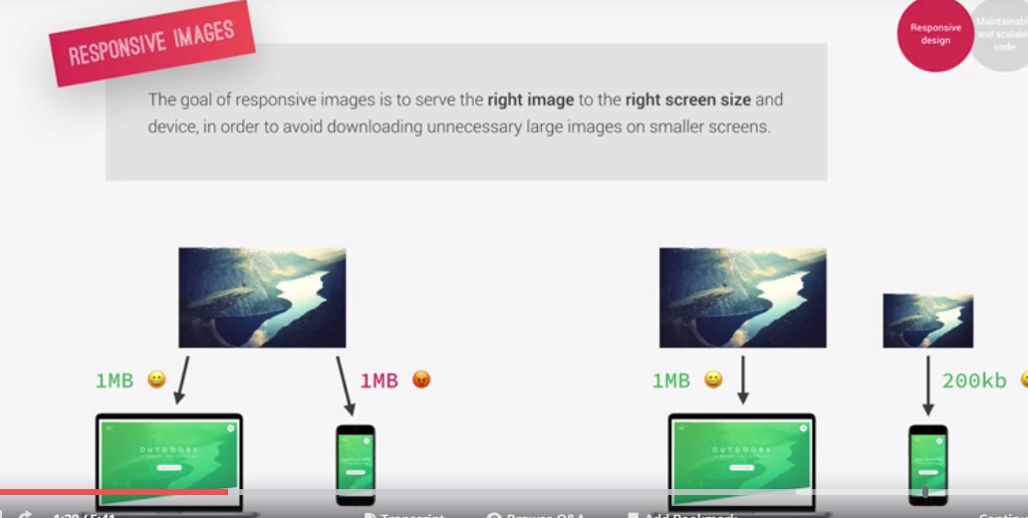

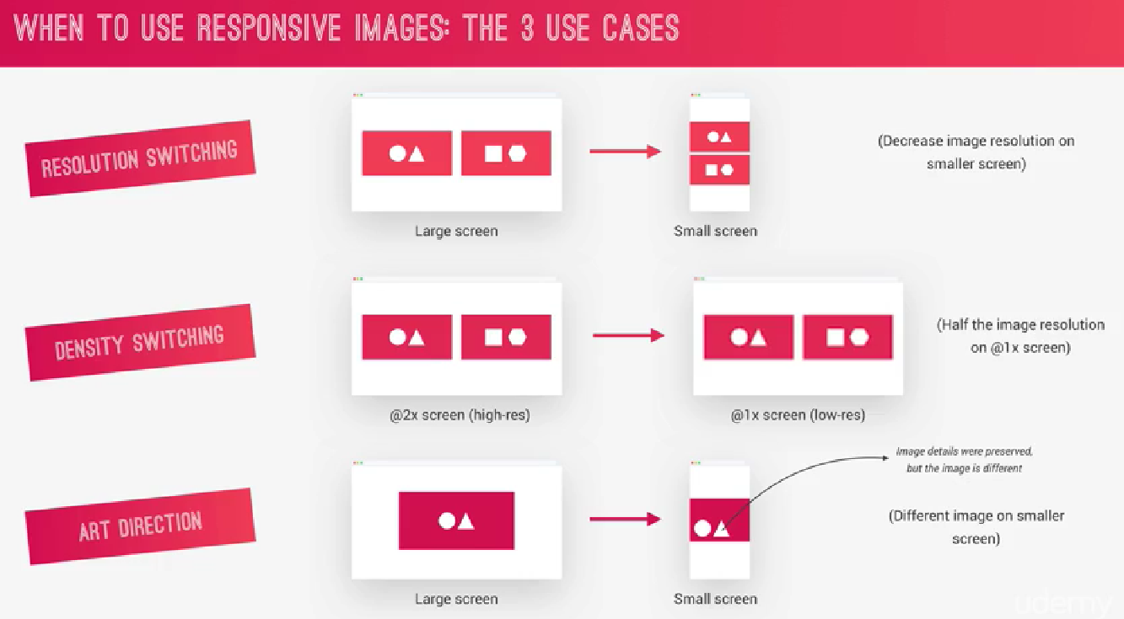

Responsive images

Density switching



For low resolution screen (selctor 1x) will use 1x.png, for high resolution screen (selector 2x) will use the 2x.png

Art Direction

Use one image on one screen width and another image on other screen width

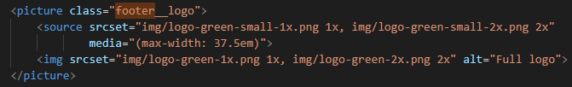

Source tag, media att gets a media query, when the width is smaller than 37.5 em then it will use logo-green-small image, if is bigger than, it will use the logo green one.

Resolution and density switching

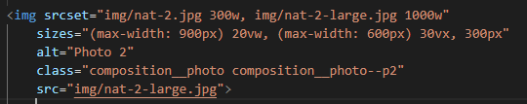

300w, 1000w actual size of that image (300px and 1000px)

20vw, 30vw size of the image (previous one when in that max width of 900px or 600px

300px default value of the image when normal web view

Src added in case user has old browser which doesn’t recognize the srcset and sized atts

Responsive images with css

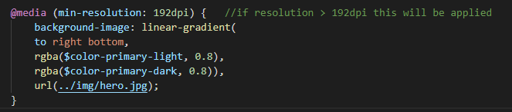

Inside the actual css so no need to import it

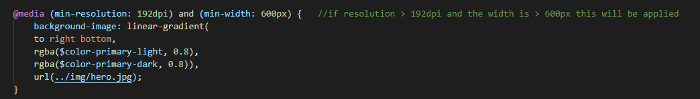

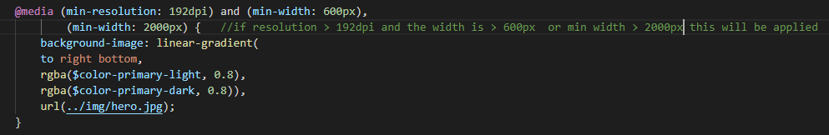

Graceful Degradation

@supports

Cases where used css is not available in the browser, then offers a reduced option for them

@supports(property to be tested if its available or not) inside will be what we want to happen in case it is supported

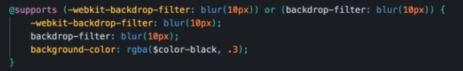

Background color applied if its supported

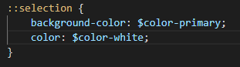

Change selected text



Need for responsive pages, if not added on the html then it will try to set the width to the biggest element in the page and start from there

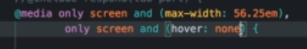

Can identify if user can hover or not on his device

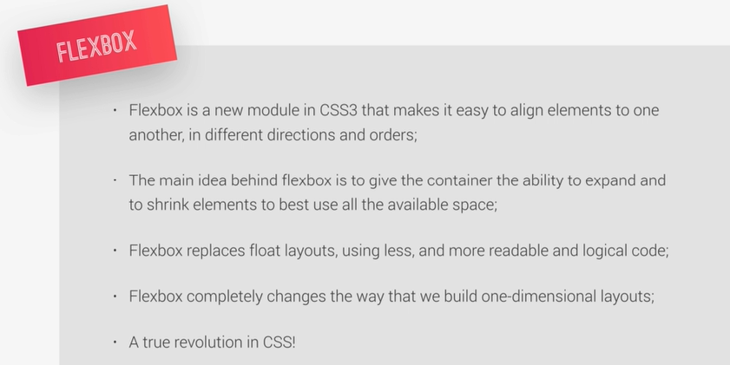

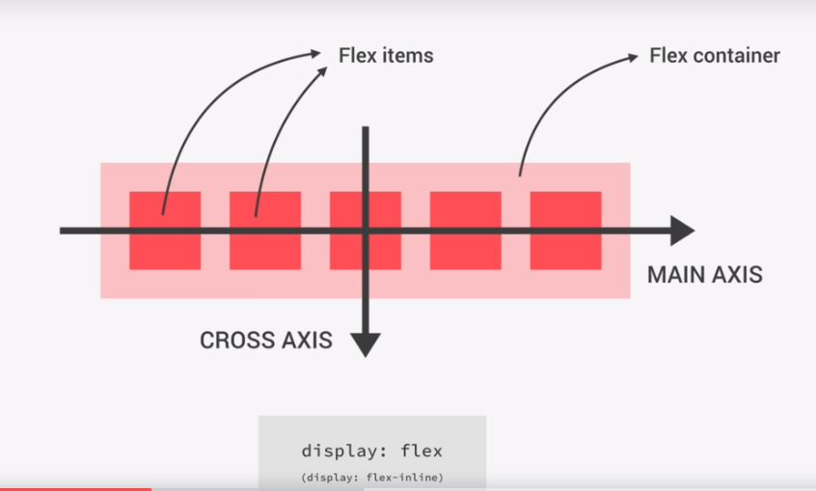

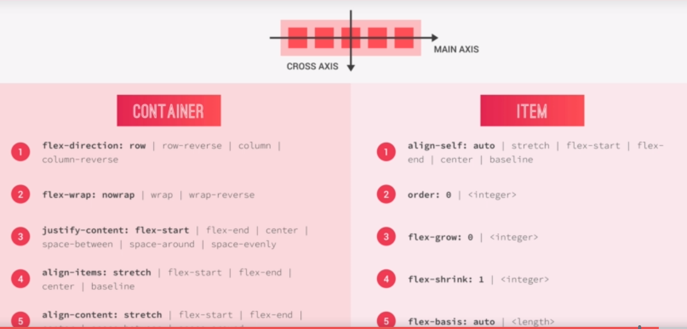

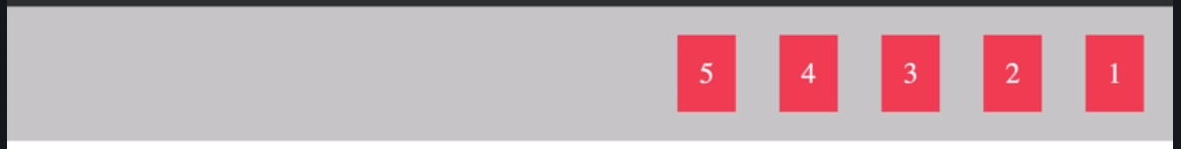

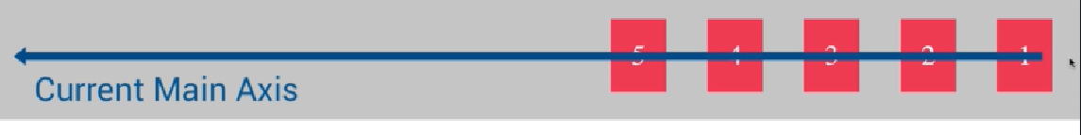

(margin on the items if not they will be one after the other)

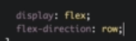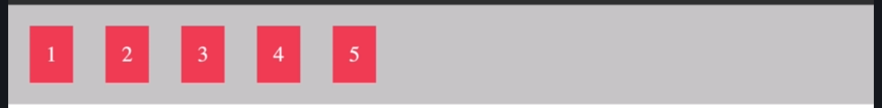

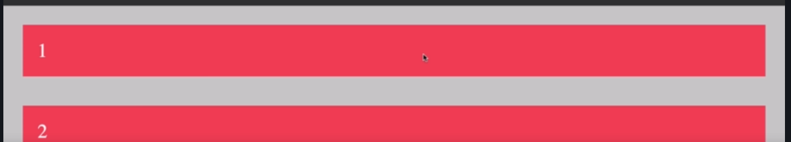

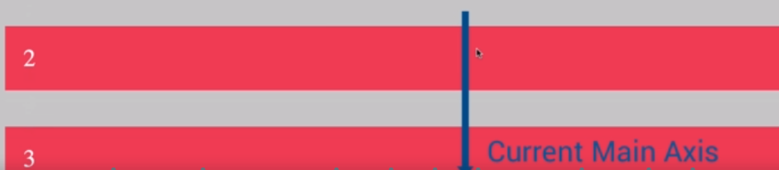

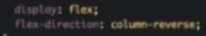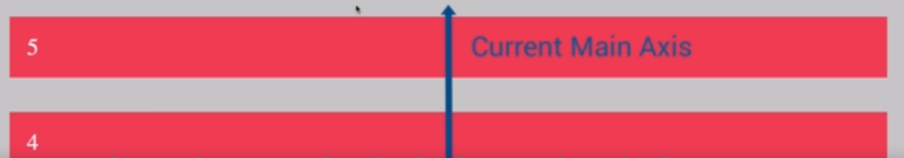

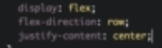

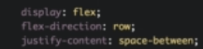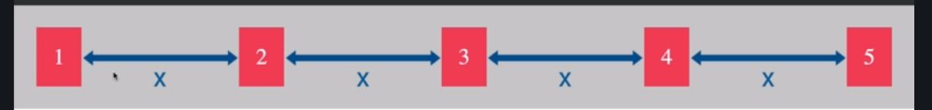

(already responsive)

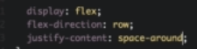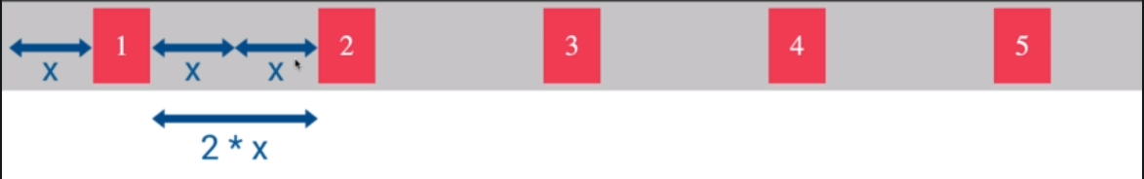

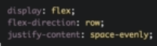

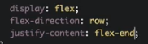

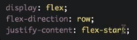

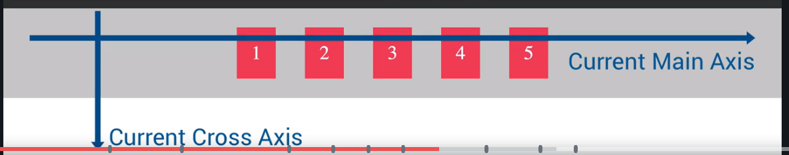

Align items works based on the cross axis

Height on element 2 is bigger

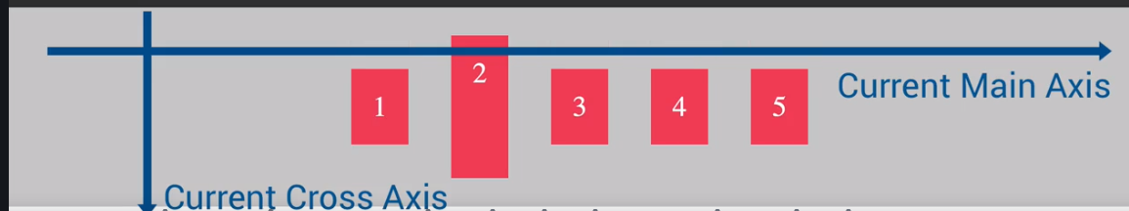

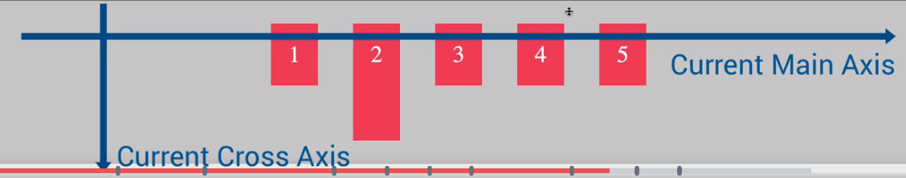

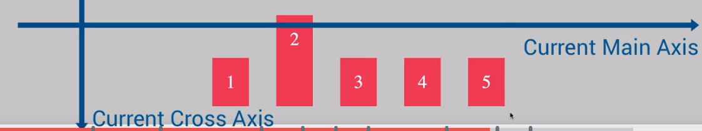

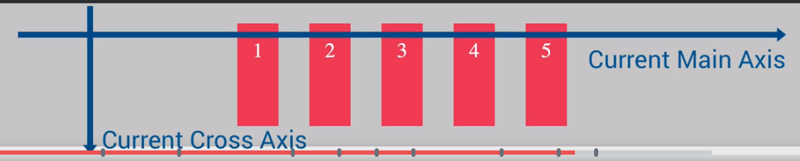

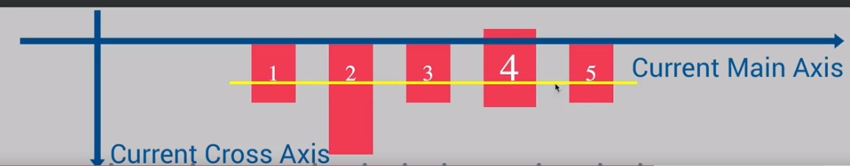

Align base on the text

Overwrite aligment for an item

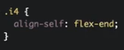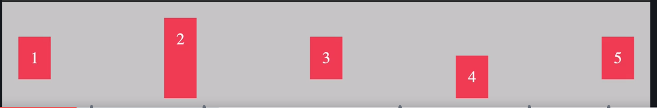

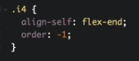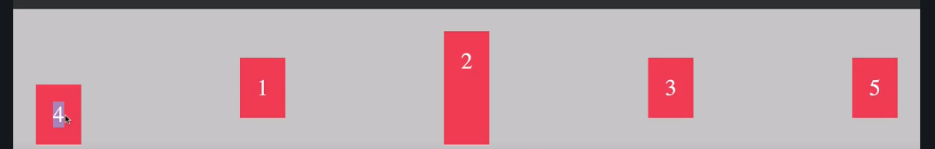

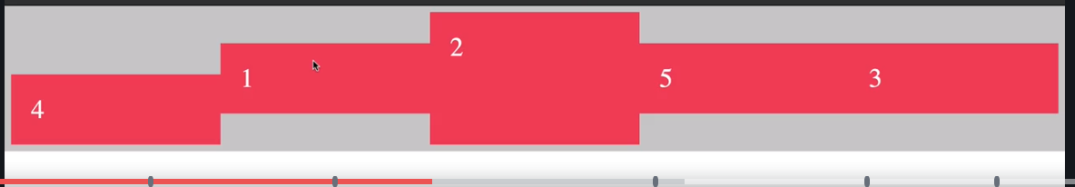

**They grow as much as they can**

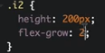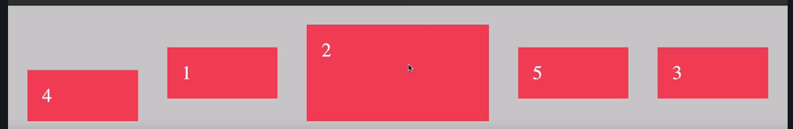

**Item is 2 times bigger**

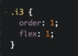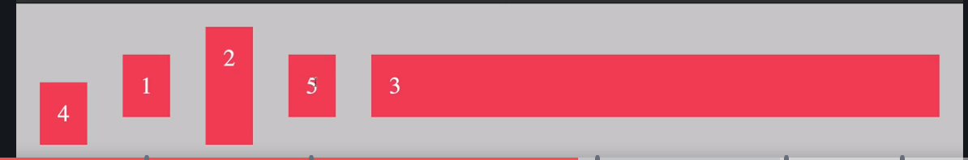

**Takes all remaining space**

**Flex basis, set the width of a flex item. If vp is reduced, the 2 is also reduced till they match the 1 width**

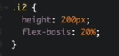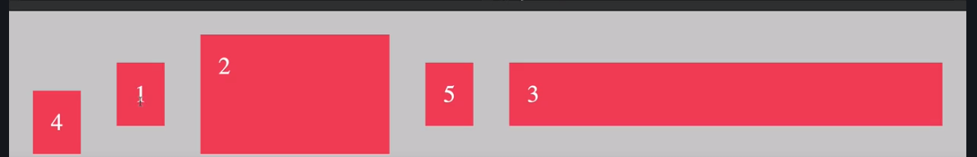

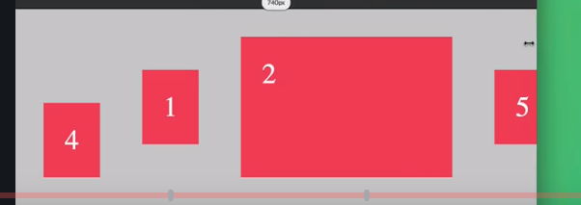

**Element wont shrink on resize**

**Flex: Flex grow, shrink, basis**

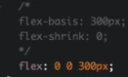

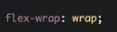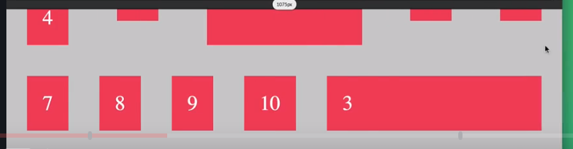

**It will create a new line for those flex items that no longer fit the container (default is no-wrap)**



**Rows on container get together**

**Css variables (custom properties)**

**Variables inside a selector, it will be available on that selector and its children**

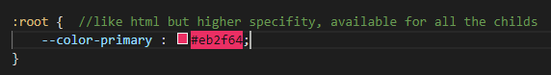



Icon fonts generates some errors like with screen readers, so move away to svg

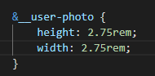

Change size of the svg icon

Header is the parent of the elements we want to align, so that is the one which will use display flex

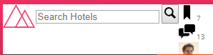

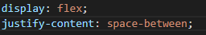



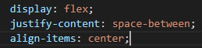







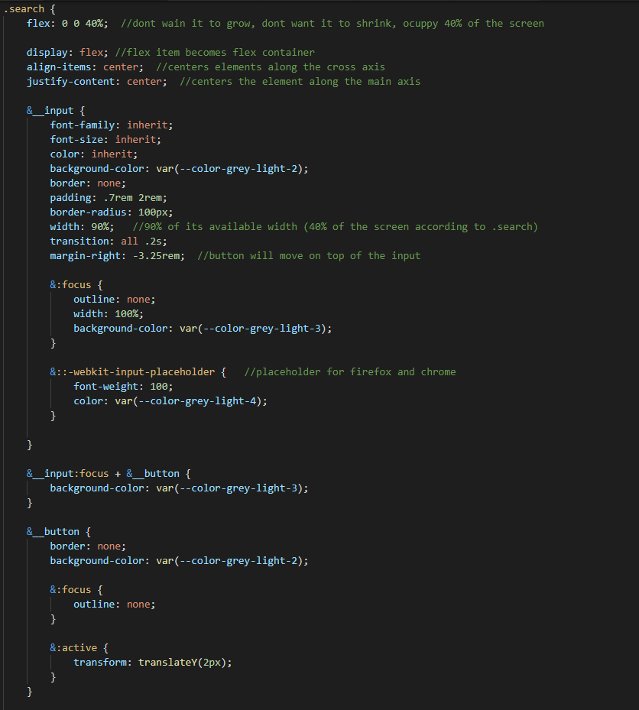

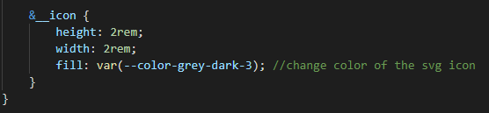

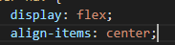

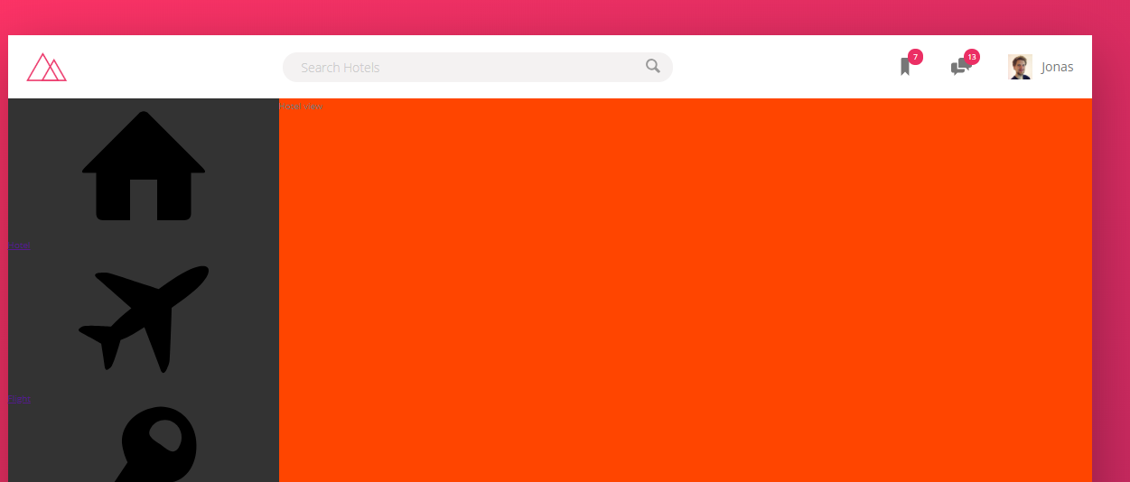

Added some icons made the height of the content increase on both sides, this Is the way flexbox works

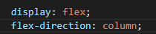

Change direction from the main axis from left to right to top to buttom.

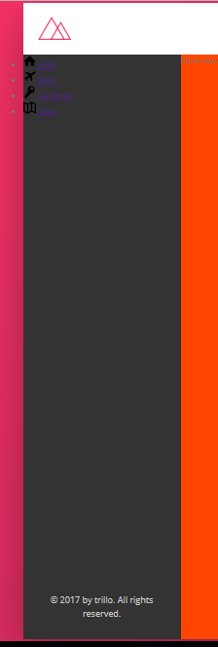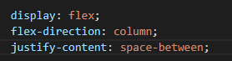



Color of the current element or the parent element

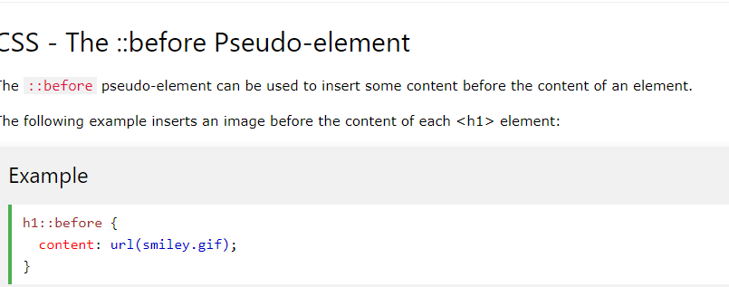

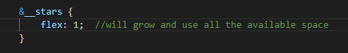

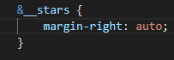

Infinite loop scaling a bit

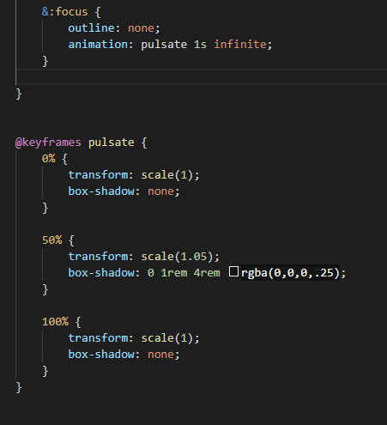

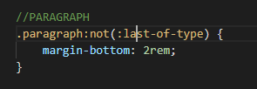

Applied to all paragraph class elements except the last one of that type

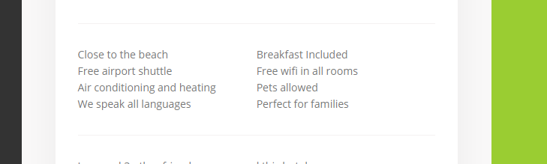

2 list items on each row:

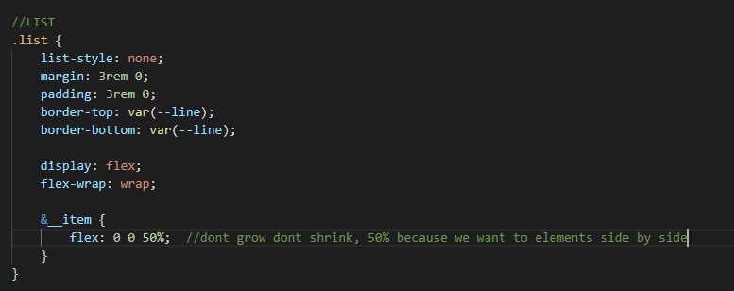

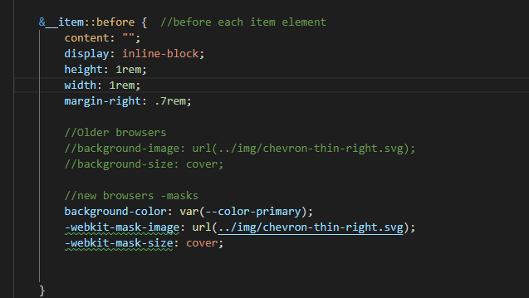

Svg icon on css

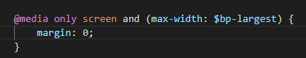

Media query when width is less than 1200px

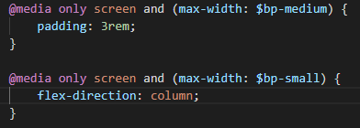

2 breakpoints then the bigger above, the last one would overwrite if both apply

Both will apply in this case since it is different property, if both were padding, then the second one will apply

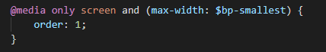

Chance the order of the flex items

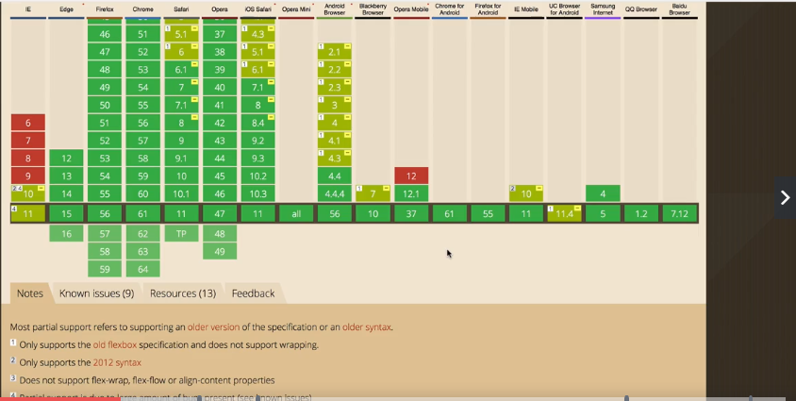

Flexbox not supported for all the browsers.

CSS Grids

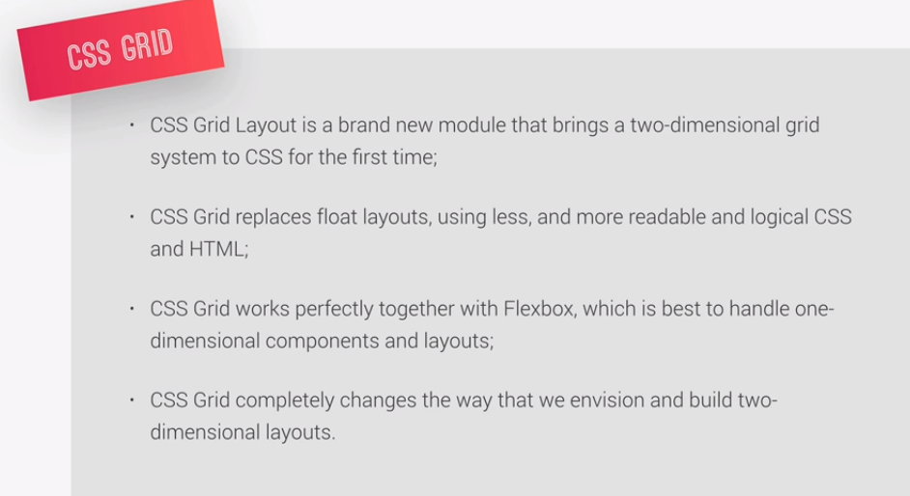

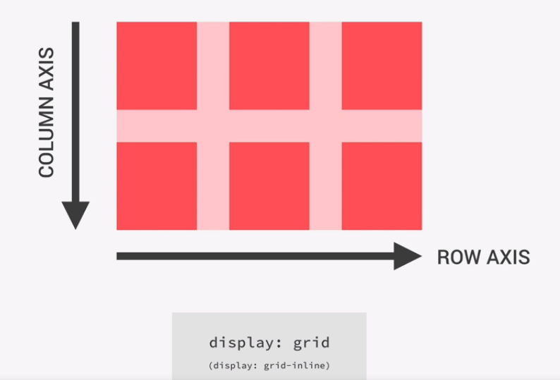

Axis cannot change

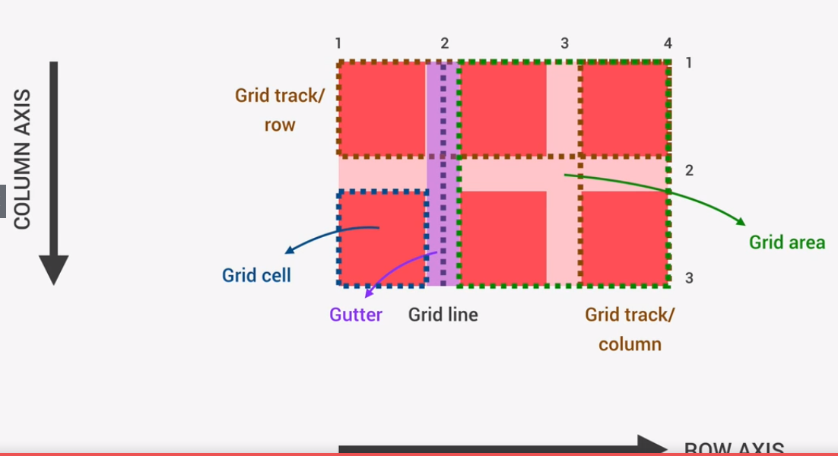

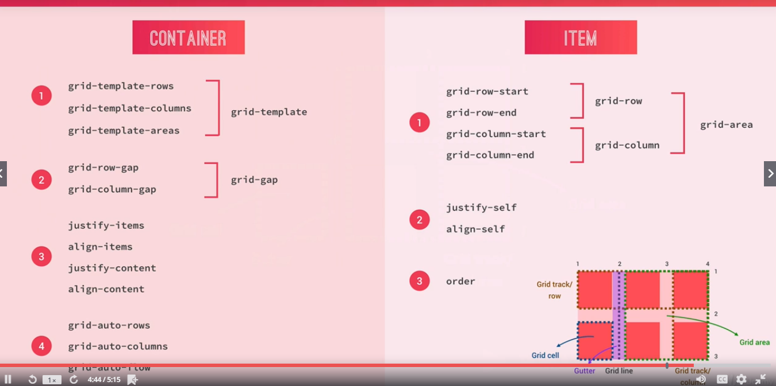

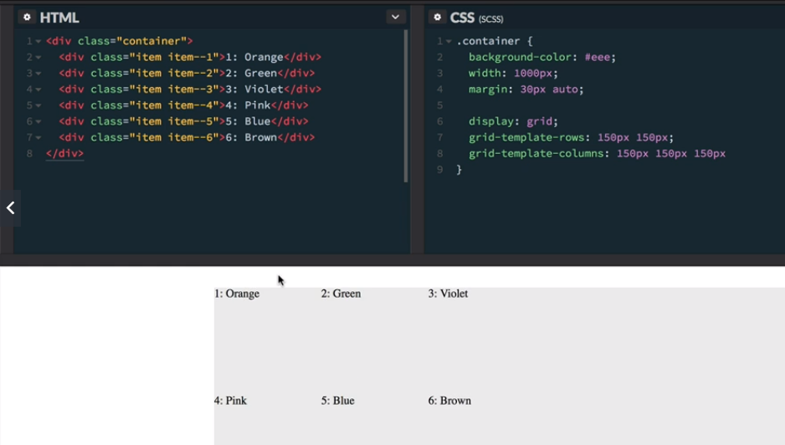

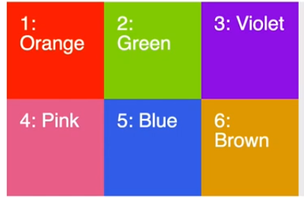

2 (template-rows) *3 (template-columns)



First value for first row, second value for second row

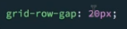

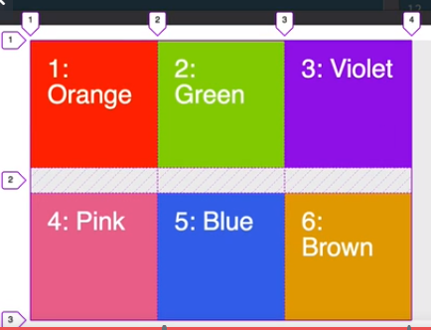





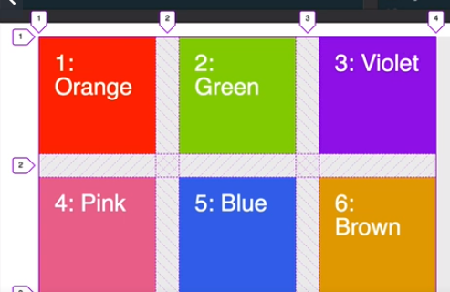

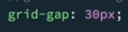 same than row and column at once



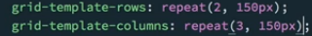

Repeats 2 and 3 times 150px row and columns



2 of 150px, 1 of 300px

Fractional unit (fr) fraccion of the available space



1fr Expands to the remaining space

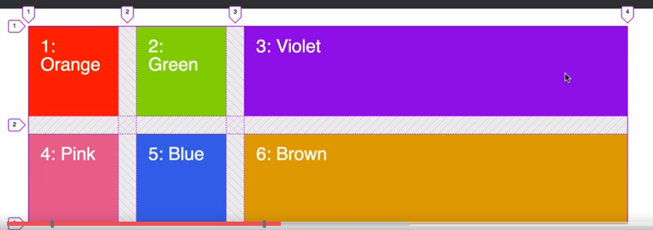



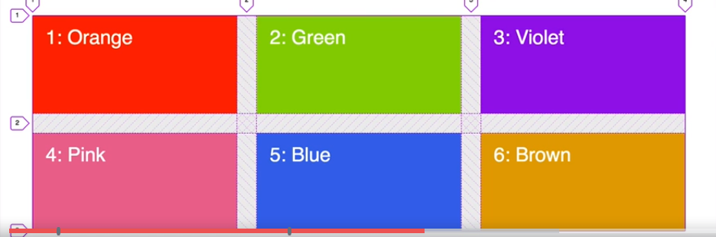

3 columns same size using all remaining space



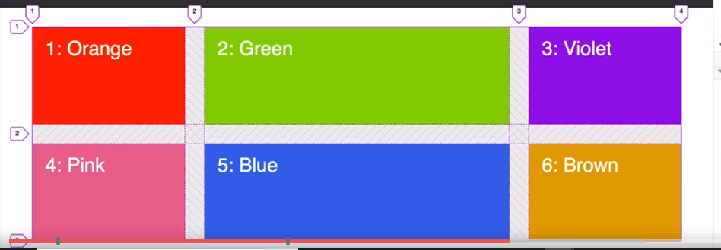

4fr, 2 will get the half 1 will get a courter



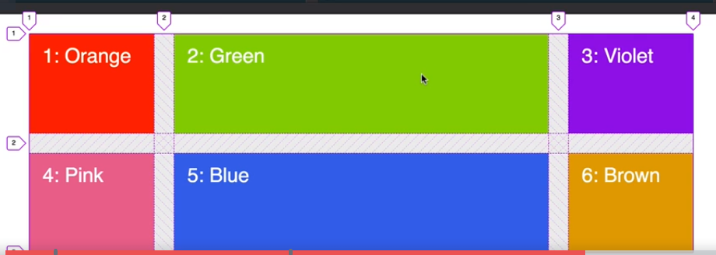

+

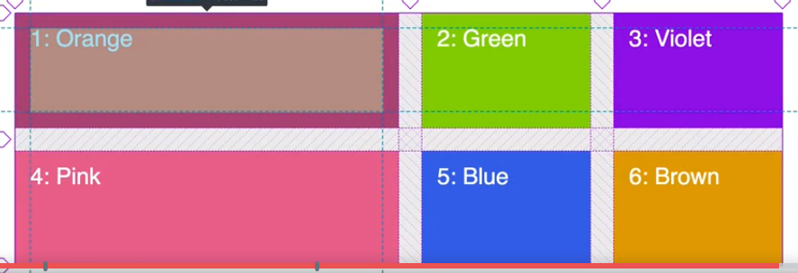

% doesn’t take consideration of the gap size, fr does

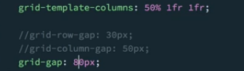

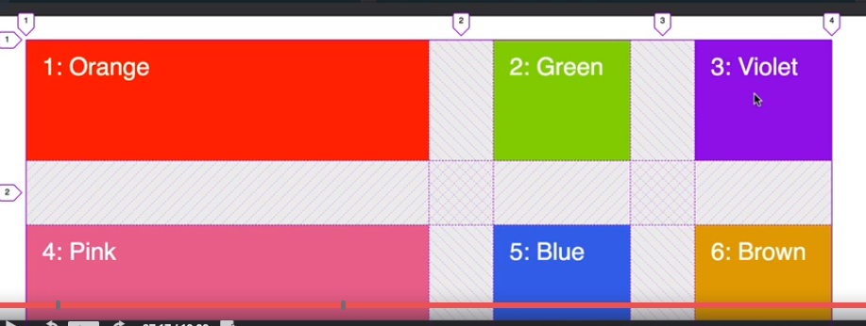

Orange takes 50% of the width 500px, from the remaining 500 px 80px are for each gap (160px) and from the remaining 340px are divided between 2 to assign to each fr

Move orange to blue position

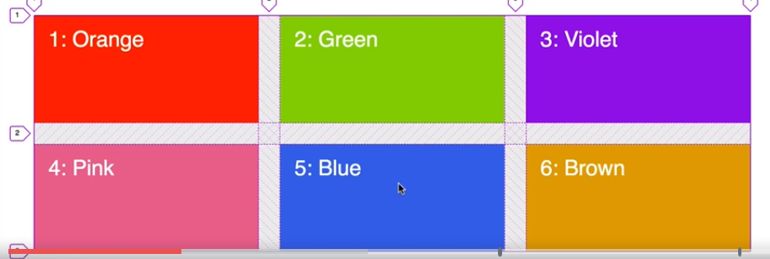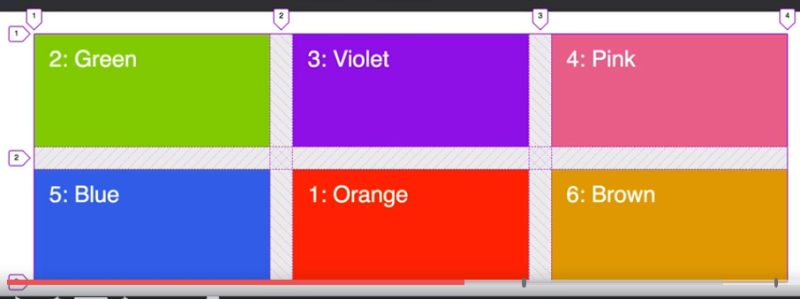

Using the grid lines as index

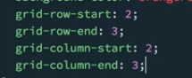 same 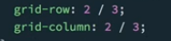

Cell will start at row 2, ends at row 3, column 2-3 also

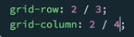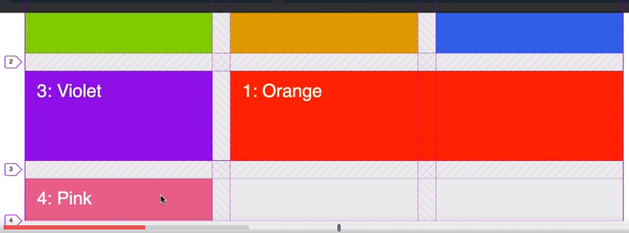

Takes 2 cells and the next element is moved to the next position

If you specify the same location for example to 2 cells, then both will occupy the same place overlapping

 to specify which one you want on top

from column 2 all the way to the end

Naming grid lines

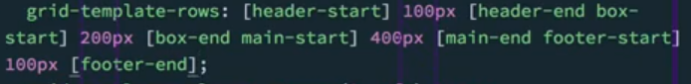





Converted to col-start-1 to 3

Name grid areas

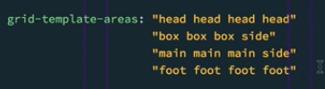

One word for each cell. First for words are the first row



Alignment of grid items to grid areas

 On grid container vertical aligment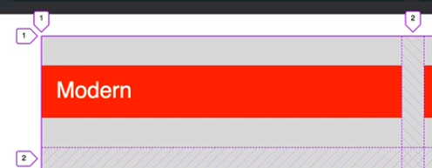

default 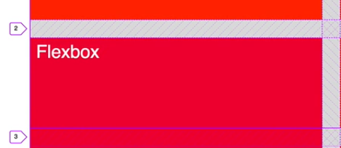



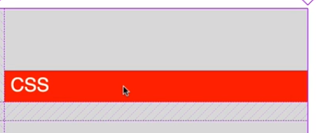

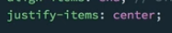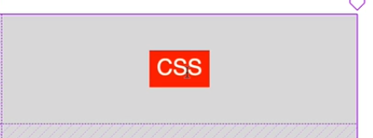horizontal aligment

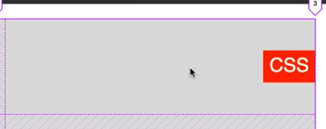

override container align items for 1 cell

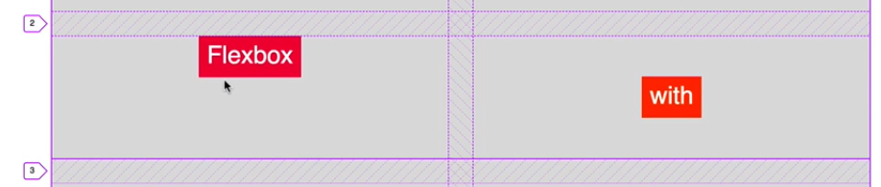

override justify alignment for 1 cell

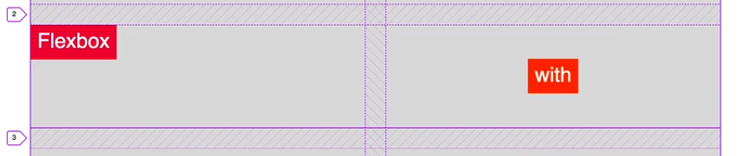

Aligning grid tracks to grid container

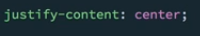center grid tracks according to the container

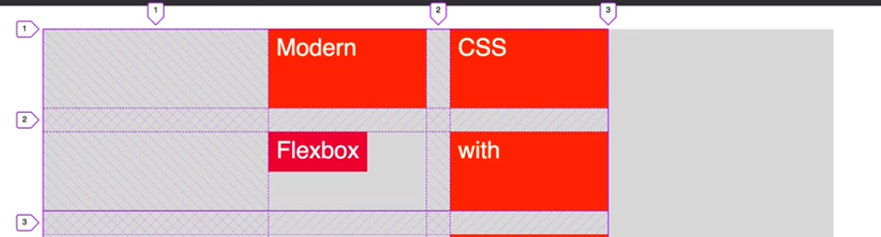



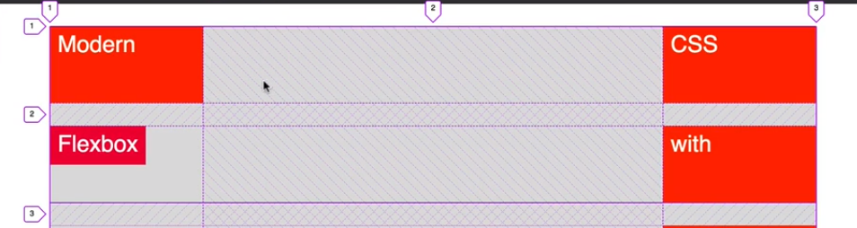

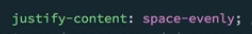

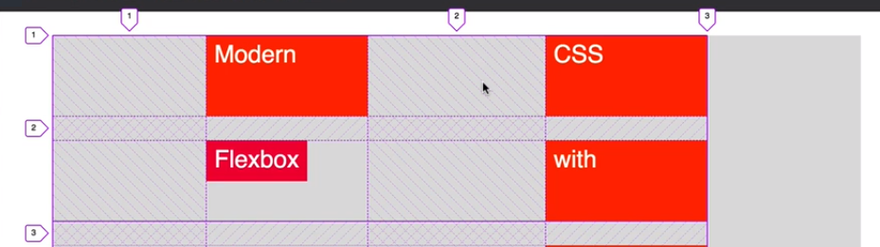

 align the rows

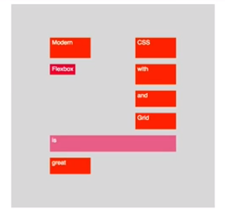



No holes in the columns or rows

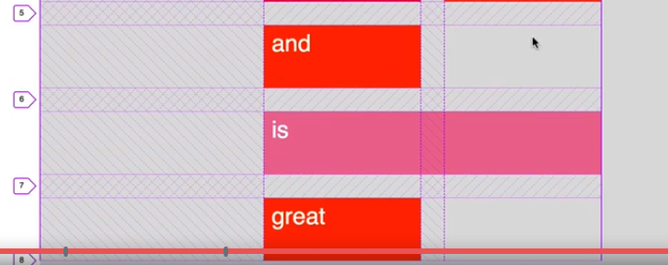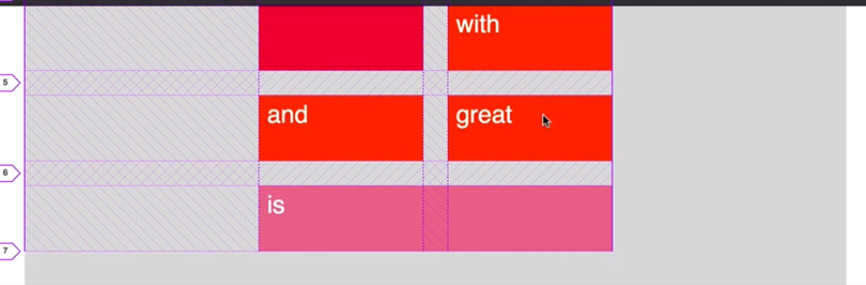

Explicit grid

We explicitly defined how the cells should look like

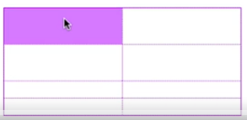first 4 explicitly defined

If we have more grid items than we have space, css grid automatically adds some more tracks to the grid so that we can then fit all of these remaining items. (implicit grid)

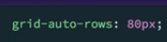automatic added tracks (implicit grid) are affected by this



Implicit items are now added as column not rows

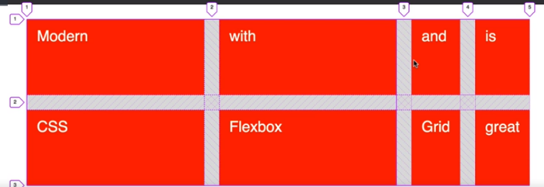



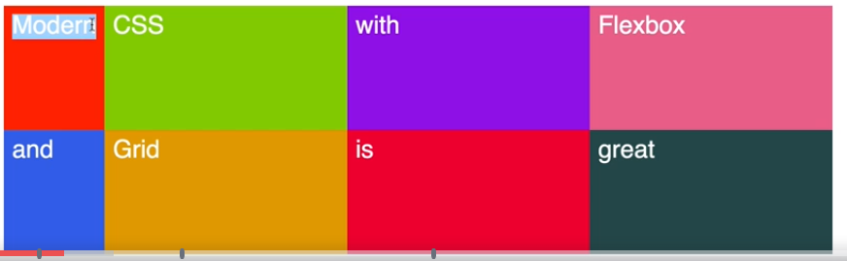

Makes the column as width as it needs to fit the content



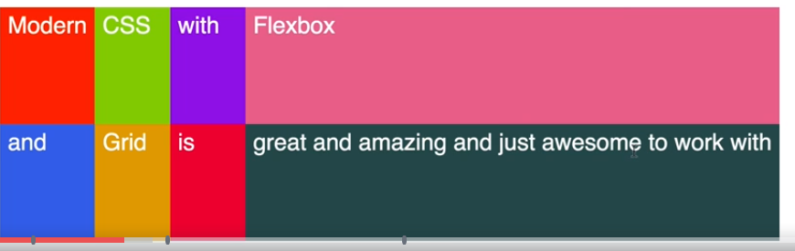

Min-content, bigger word is used to fit the min content (awesome in this case)



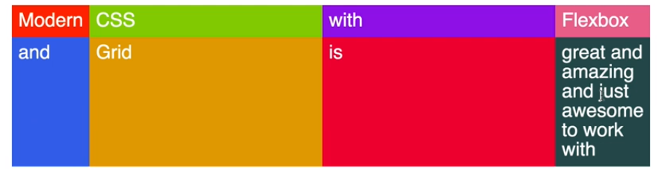

Min, max function, grids will make sure that the tracks stay between these values



At least 150px and at most the min content required to fit

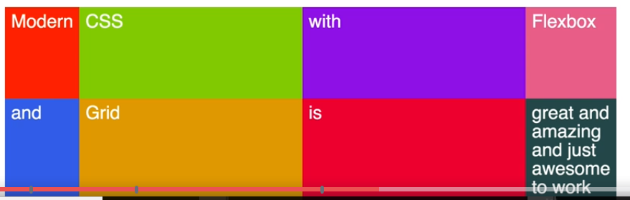

Auto-fill

Automatically decides the number of tracks which fit



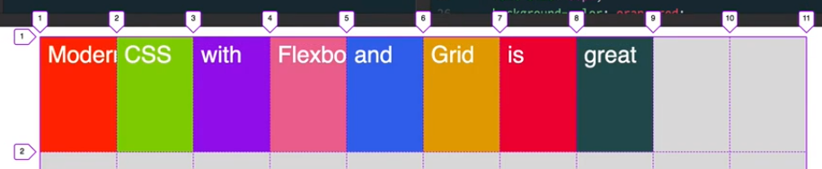

10 tracks since the content is of 1000px and the column width is 100px

Auto fit – collapse

Collapse cells with no content and make them with width of 0

Still 10 tracks but the ones with no content are collapsed

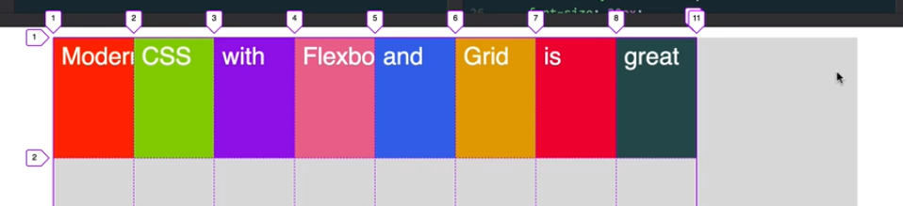

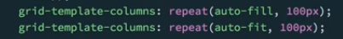

Responsive page without any media query

 from the beginning to the end

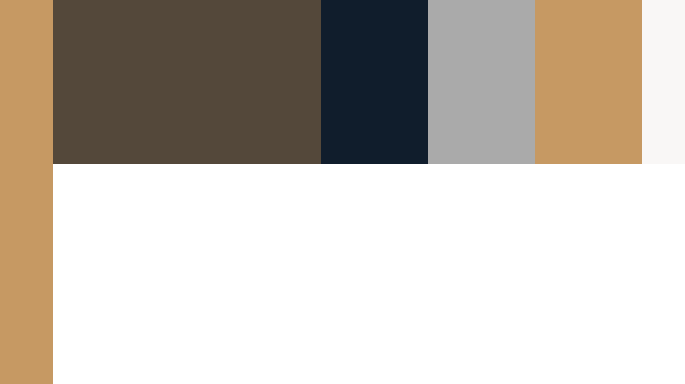

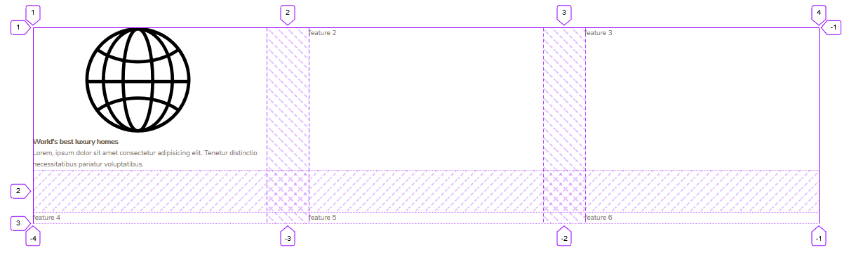

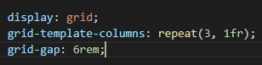

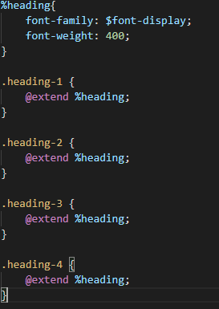 heading 1-4 will be copied inside %heading

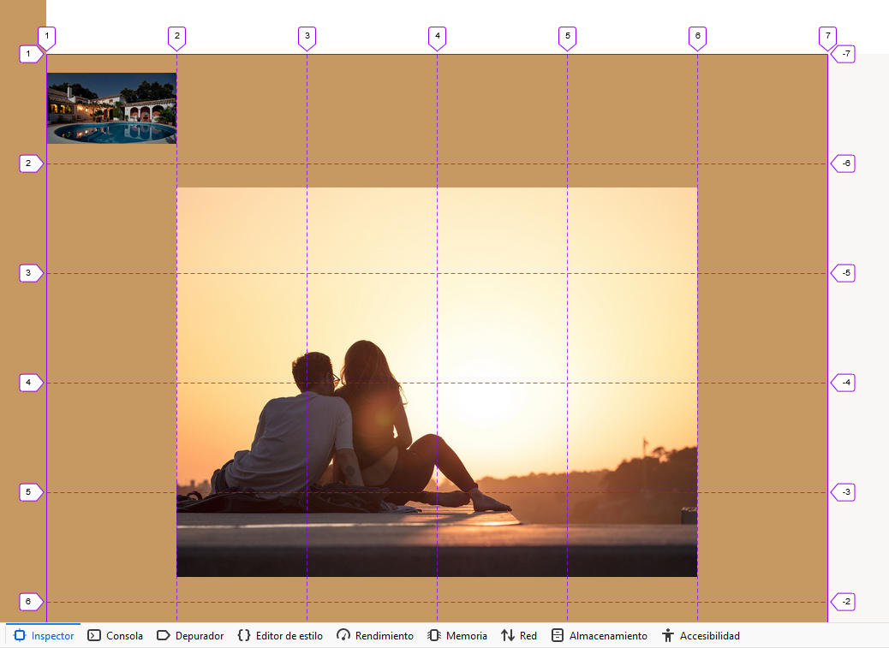

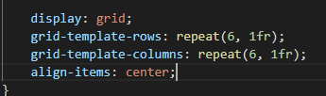



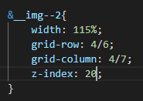

 sup moves the text a little bit up

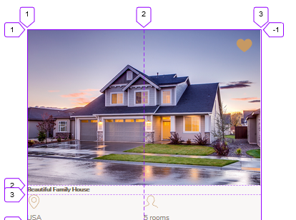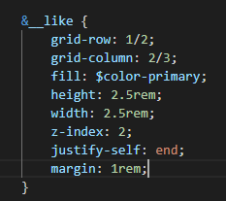

One item above other (heart above pic)

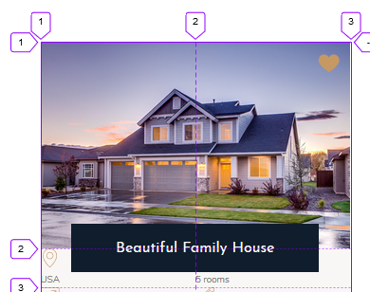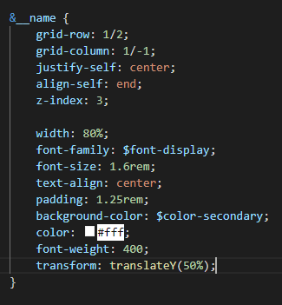

Above same first grid row but transform moves it a bit below 50%

Gaps are equal for all rows, cannot be choose individually

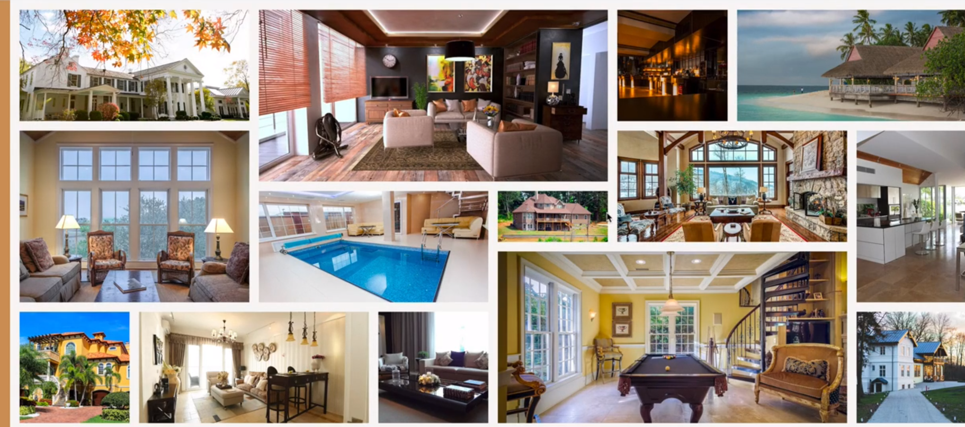

How to decide number of rows and columns? Based on the smallest element

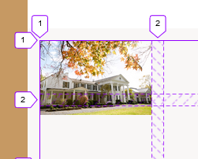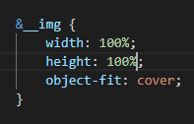-> 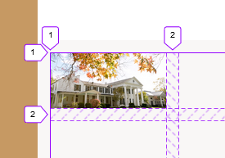

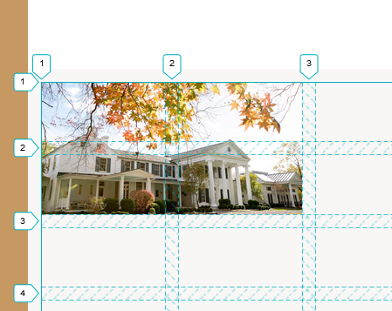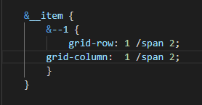

 default 100% image gets darker

 text can be a grid item

If display:grid on header__seenon-text, it will be a grid with 1 item

Before and after pseudo elements can also be items of the grid

